PRO STICKERS USERS GUIDE

Version 2.0

Contents

1. Login: Master Portal 3

2. Home Page: Master Portal 3

3. User Creation: Master Portal 4

4. Edit user: Master Portal 5

5. How to make a user Active/Inactive 6

6. Add color: Master Portal 7

7. Edit / Delete a color: Master Portal 8

8. Pre-Defined Price: Master Portal 9

9. Login: Designer Portal 9

10. Home Page: Designer Portal 10

11. Availability Time: Designer Portal 10

12. Customer Portal: Login 11

13. Create Appointment: Customer Portal 14

14. Customer Appointment: Designer Portal 19

15. Designs: Customer Portal 25

16. Order: Customer Portal 30

17. Order Tracking (Master/Designer) 31

18. Customer Portal: Customer Feedback 32

19. Sales Report: Master Portal 34

20. Design Detail: Customer Portal (Order Placed) 35

21. Files: Customer Portal 36

22. Customer Detail: Master Portal 36

# 1. Login: Master Portal

* Enter the URL > Screen will appear as shown > Sign in with yours google account.

(For Login as Master a unique Google ID previously saved as Master Role is needed)

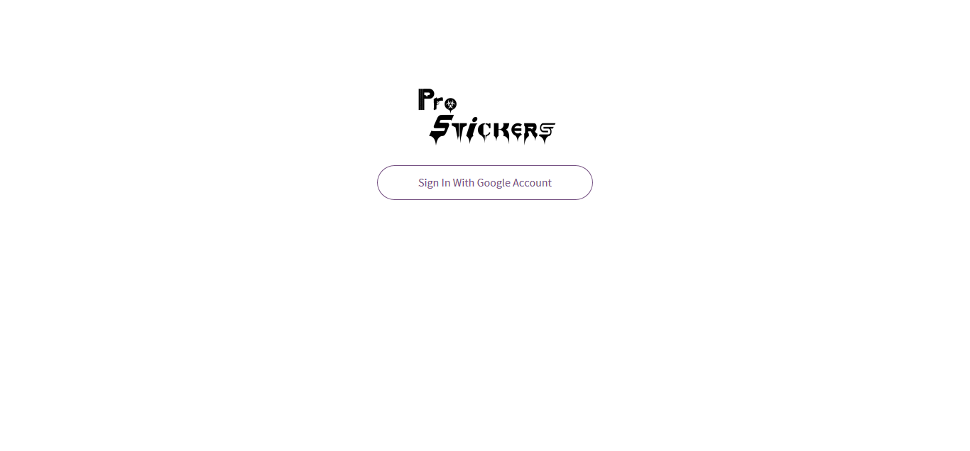

*Figure – Login Page Master/Designer*

# 2. Home Page: Master Portal

Home page appears as shown. Home page here exhibits the 5 most recent customer feedbacks.

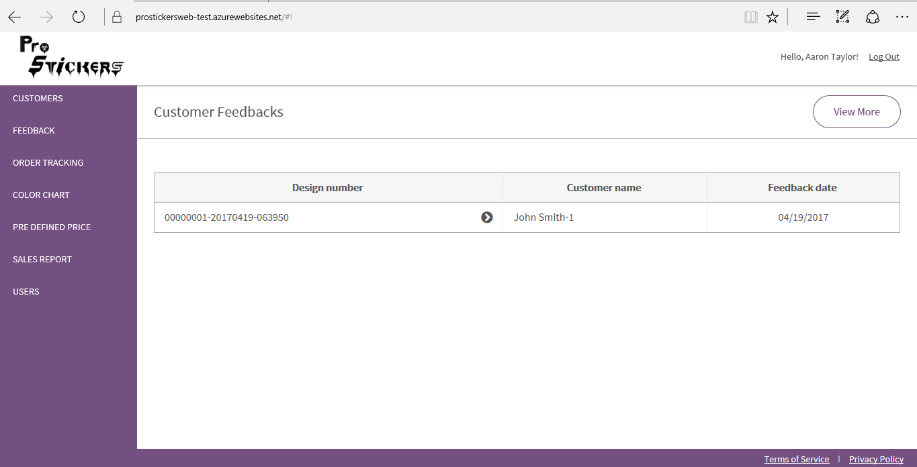

*Figure – Home Page: Master Portal*

* View Customer feedbacks and customer feedback detail.

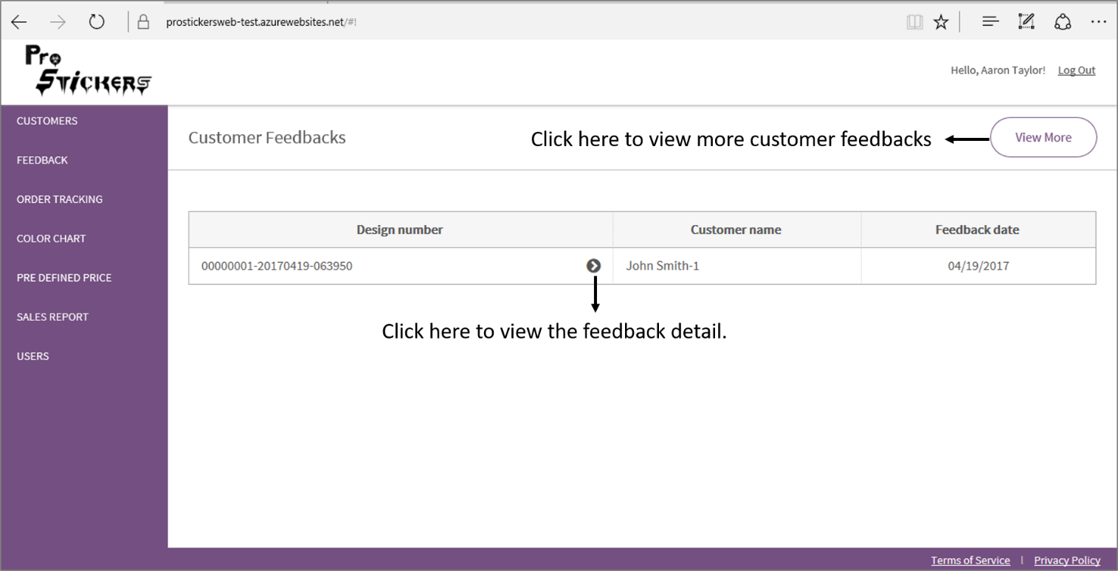

*Figure – How to view customer feedbacks and feedback detail: Master Portal*

# 3. User Creation: Master Portal

* Click on the ‘Users’ module > Add user.

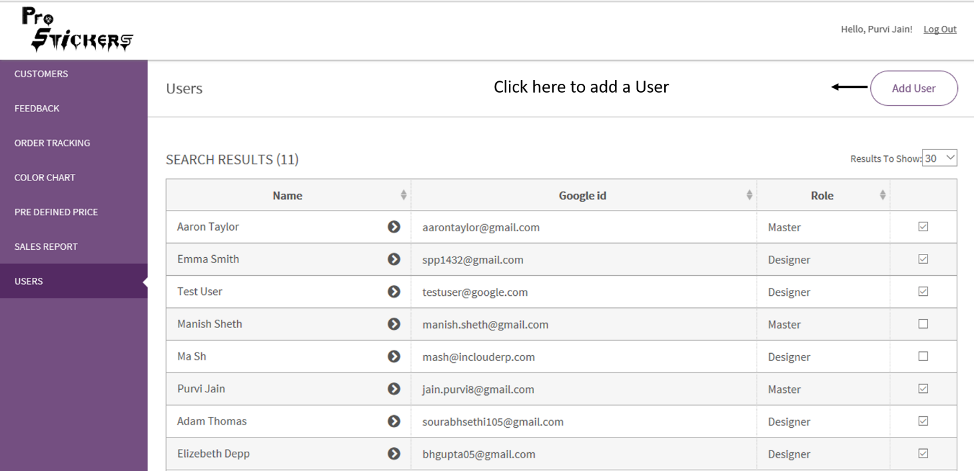

*Figure – Users Page- How to add a User: Master Portal*

* Add User form appears as shown.
* Fill the details > Click Save
* The user creation requires a unique Google Id. In this form, Google Id and role once saved can’t be edited later, other fields are editable.

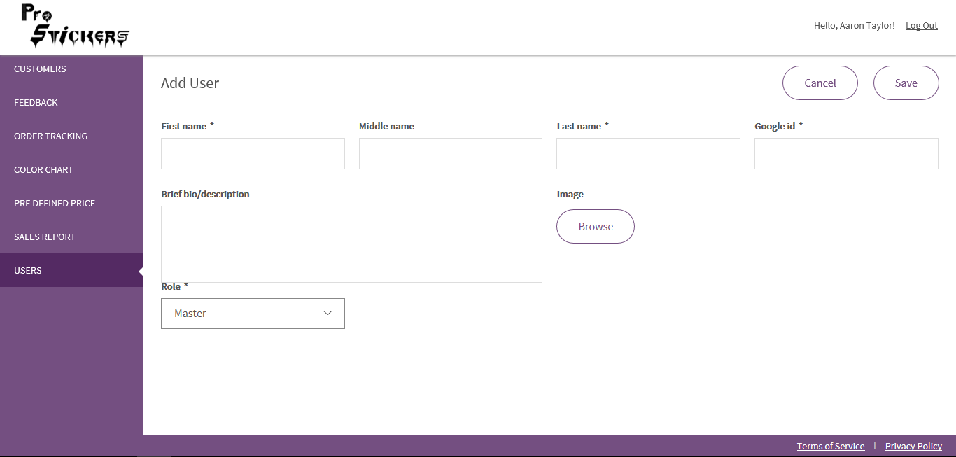

*Figure – User Creation: Master Portal*

# 4. Edit user: Master Portal

* For editing a user > Click on User

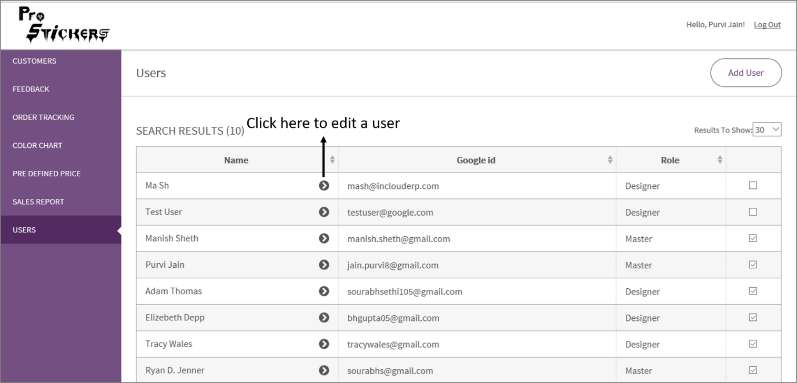

*Figure – How to edit a User: Master Portal*

* Edit user page appears as shown.

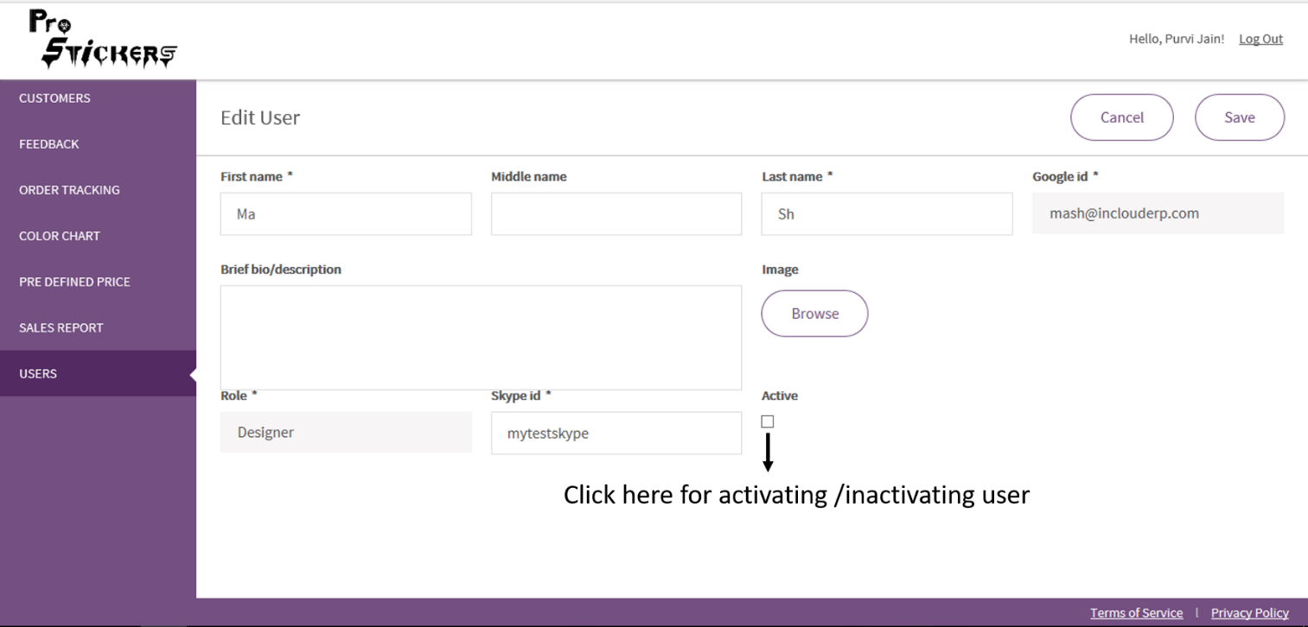

*Figure – Edit User Page: Master Portal*

# 5. How to make a user Active/Inactive

* Click on Users > Click on the box in front of the User Name (This can also be done from Edit user page).

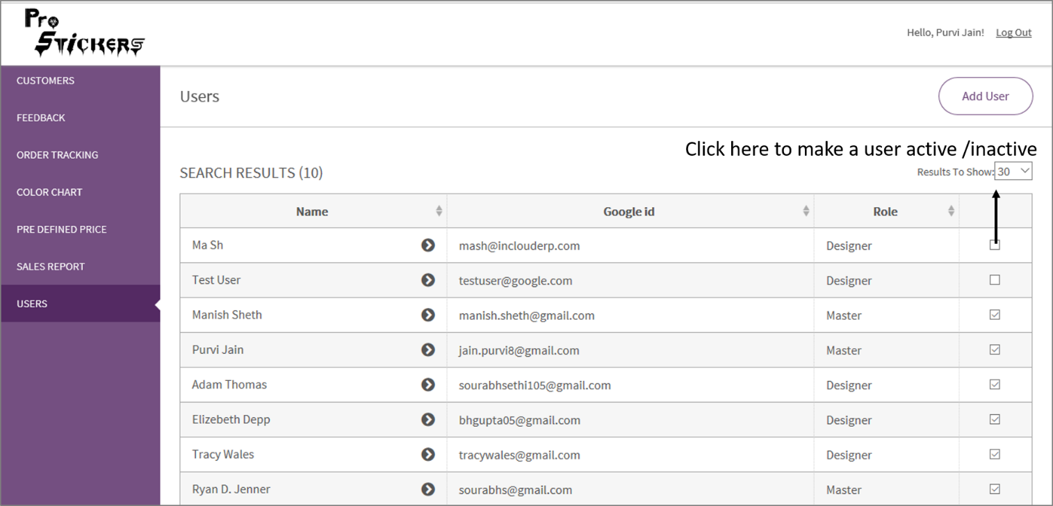

*Figure – How to make a user Active/Inactive: Master Portal*

* If a user has scheduled appointments, then a user can’t be inactivated. On inactivation, the message shown below appears.

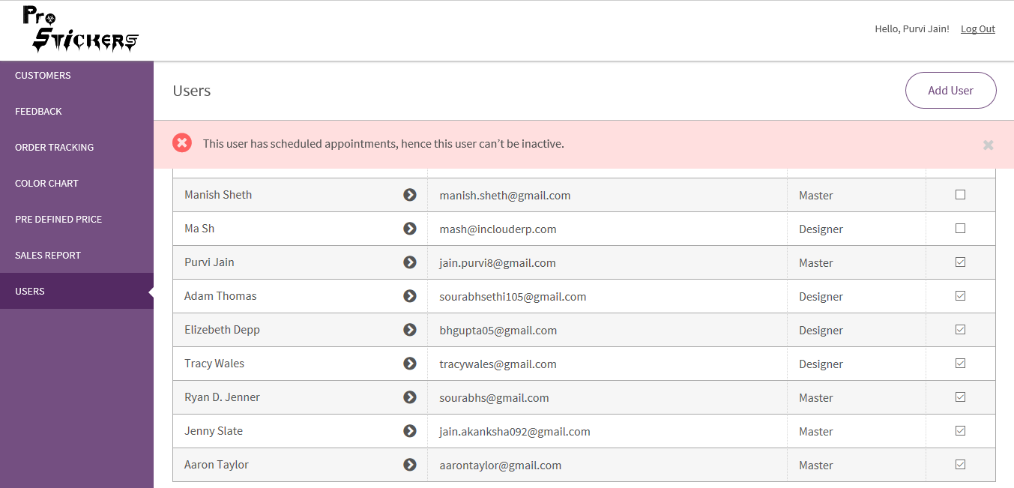

*Figure –Message shown on inactivating a user having scheduled appointments: Master Portal*

# 6. Add color: Master Portal

* Click on the ‘Color chart’ module > Add color.

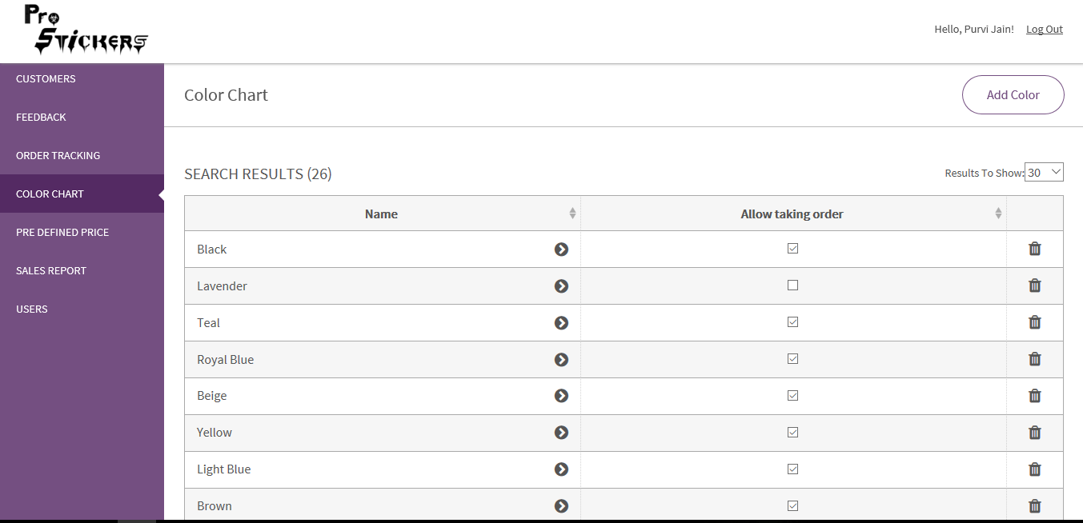

*Figure – How to add a color: Master Portal*

* Add Color page appears as shown > Fill the details required > Click Save

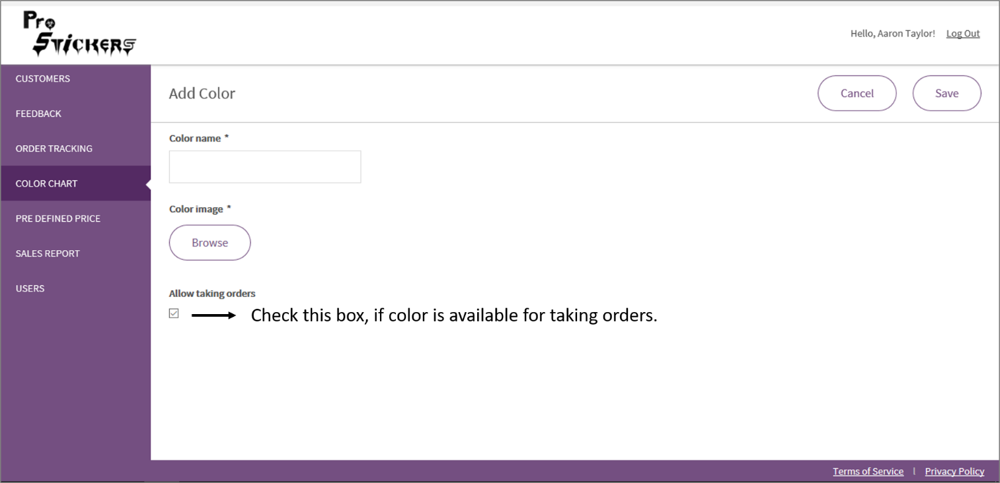

*Figure – Add Color: Master Portal*

# 7. Edit / Delete a color: Master Portal

* A color can’t be deleted if an order is already being placed with that color.
* Allow taking order checkbox is editable on the Color Chart page also.

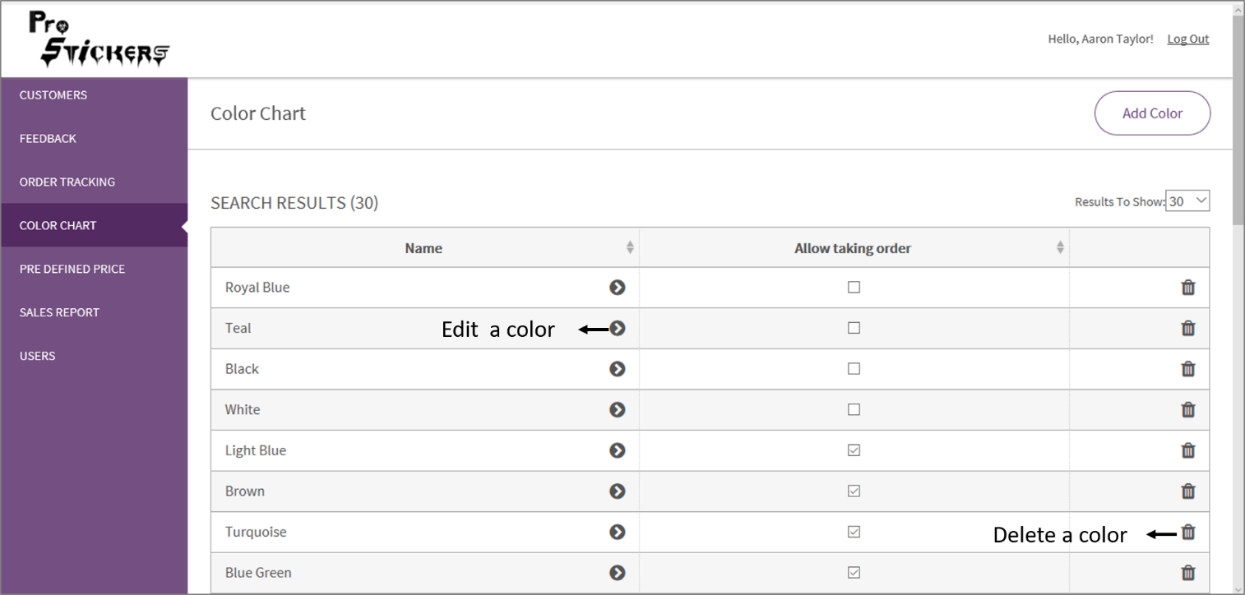

*Figure – How to edit or delete a color: Master Portal*

# 8. Pre-Defined Price: Master Portal

* A master can set the pricing based on no. of colors and size.

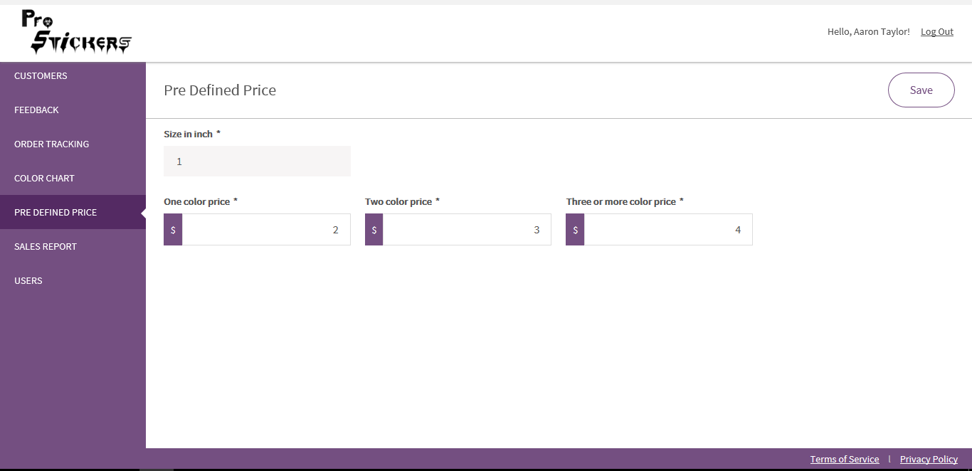

*Figure - Pre – Defined Price form: Master Portal*

# 9. Login: Designer Portal

* User can login as Designer, if his/her unique Gmail ID is saved as a Designer role.
* Only active user can login.

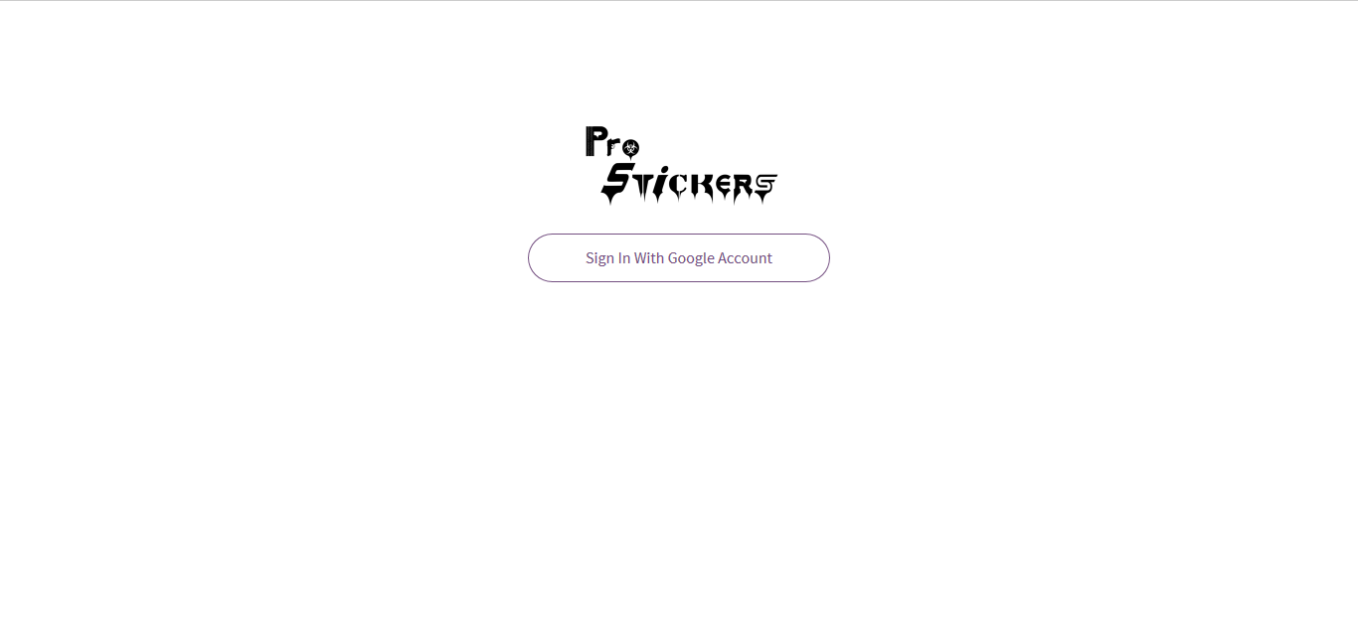

*Figure – Login Page: Master/Designer*

# 10. Home Page: Designer Portal

* Home Page exhibits the 5 upcoming ‘’scheduled appointments”.

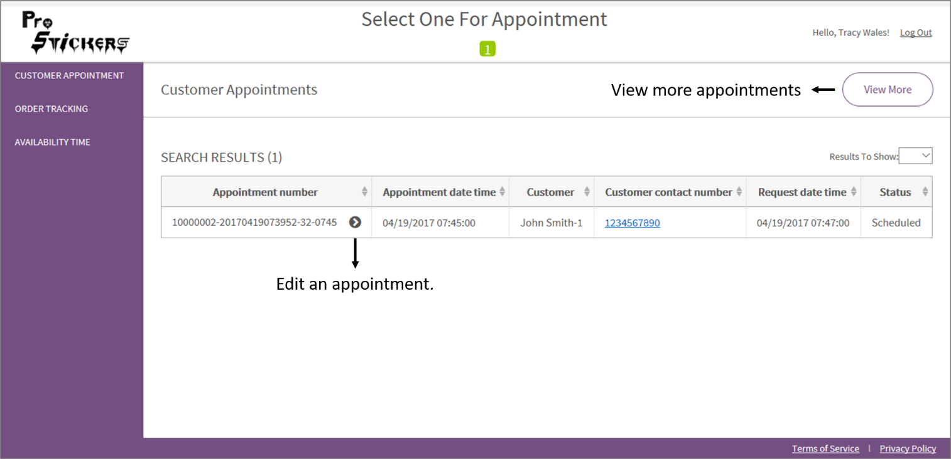

*Figure – Designer Portal: Home Page*

# 11. Availability Time: Designer Portal

* A designer can choose his/her available dates and time for the appointment.

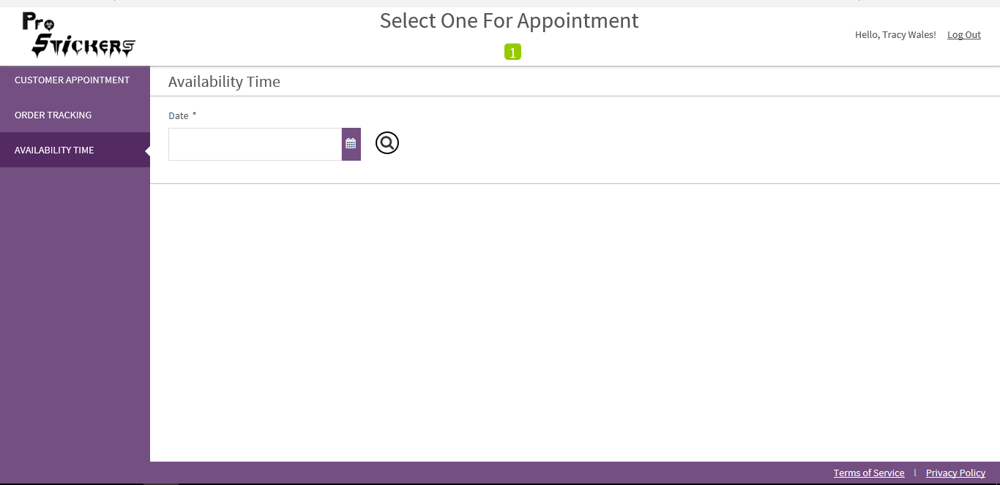

*Figure – Availability Time: Designer Portal*

* Process for selecting the available time
* Select the date
* Search
* Choose slots to be shown > Click Save
* Each slot here is of 15 mins.
* In View slots from 10 AM to 8:00 PM: 40 slots will be shown.
* In View 24 hours’ slot: 96 slots will be shown.

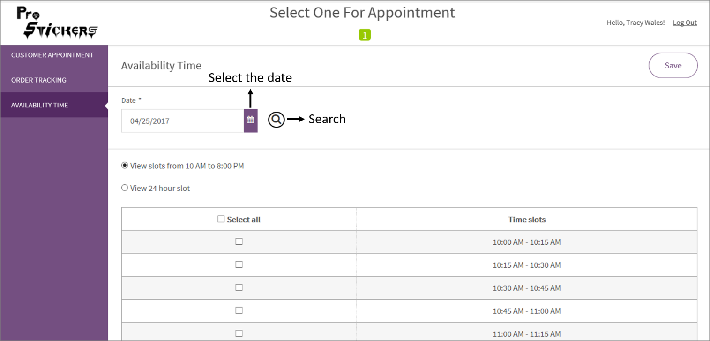

*Figure – Process for selecting available time: Designer Portal*

# 12. Customer Portal: Login

* 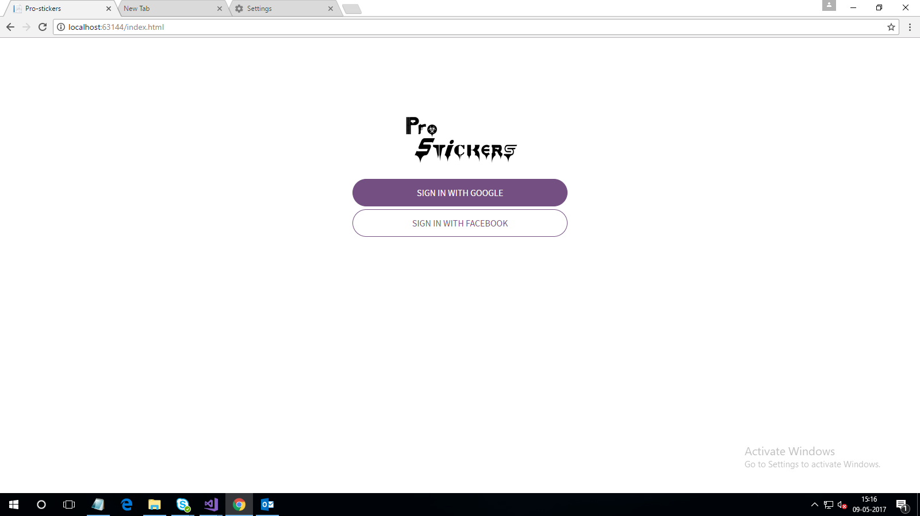Login to Customer Portal

*Figure- Customer Portal: Login Page*

* 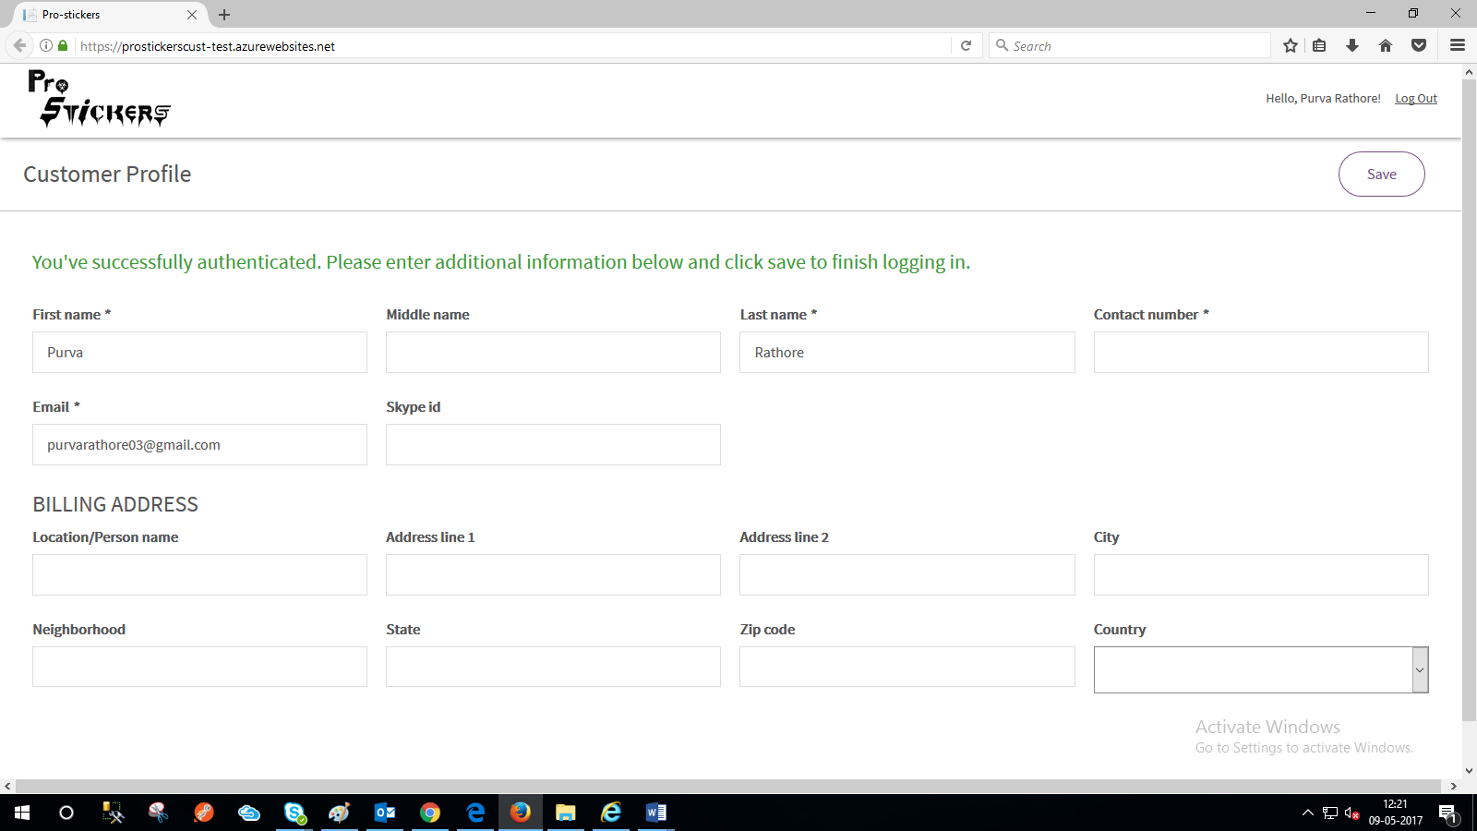 On first time Login > Page appears as shown > Update the customer profile

*Figure- Customer Profile Page: Customer Portal (First time login)*

* Home Page appears as shown.

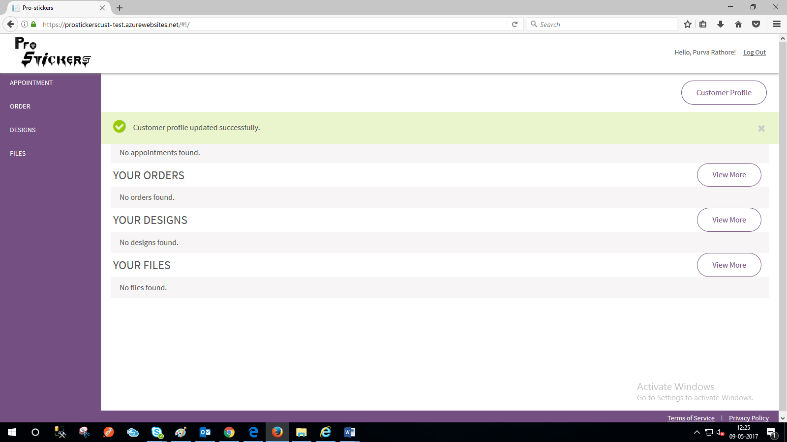

*Figure- Home Page: Customer Portal (First time login)*

* Customer’s Portal Home Page (After Appointments etc. Details have been entered) shows 3 most recent:
* Appointments
* Orders
* Designs
* Files

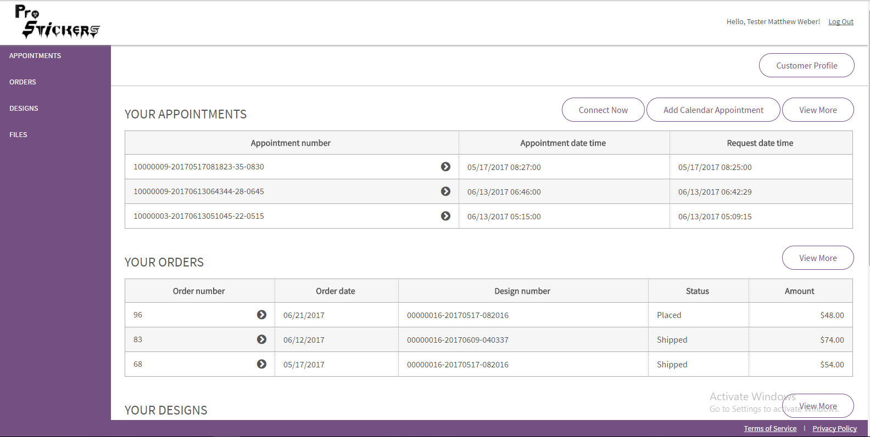

*Figure- Home Page: Customer Portal (Second time login)*

* Click on Customer Profile
* Customer Profile page appears as shown

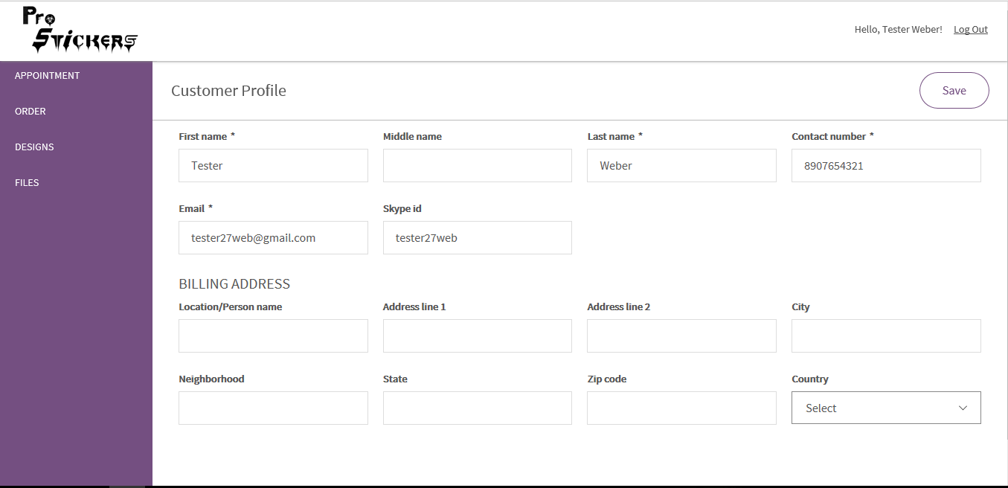

*Figure- Customer Profile Page (Second time login)*

# 13. Create Appointment: Customer Portal

The appointment can be created in 2 ways

* Click on ‘Connect Now’ button

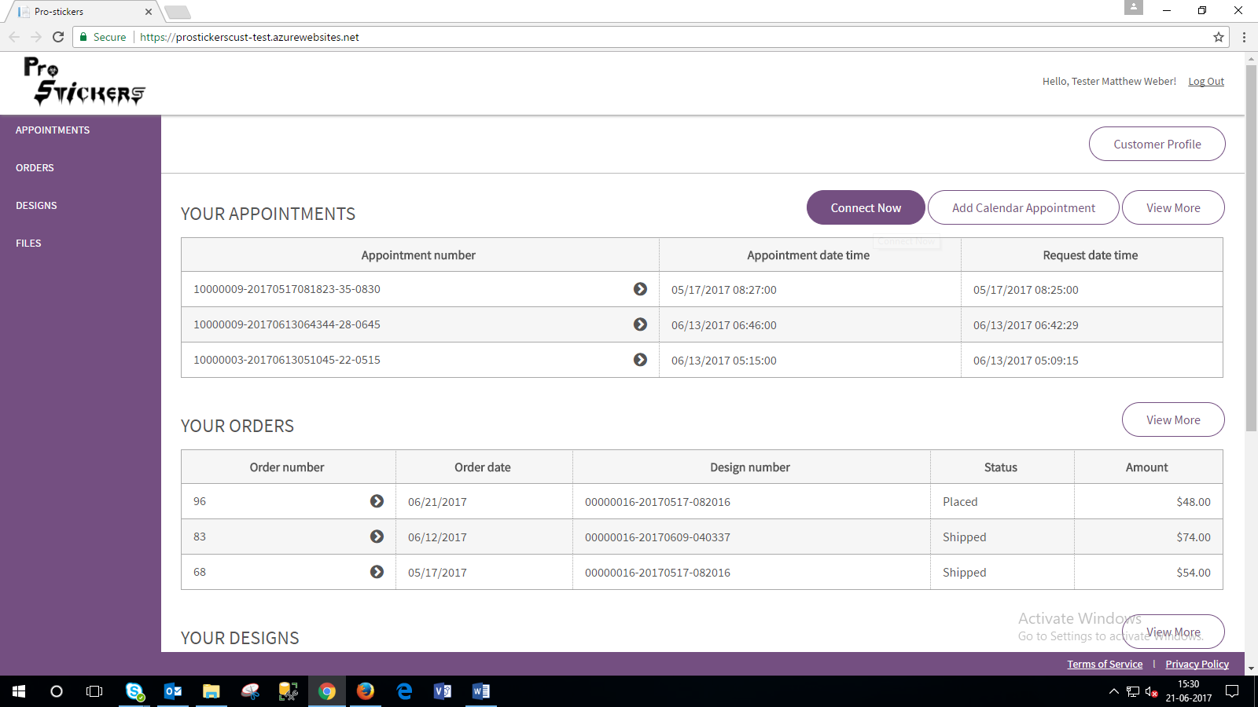

*Figure – Creation of appointment by clicking on ‘Connect Now: Customer Portal*

* A message showing added to the queue will appear. It will show “real-time” queue number.

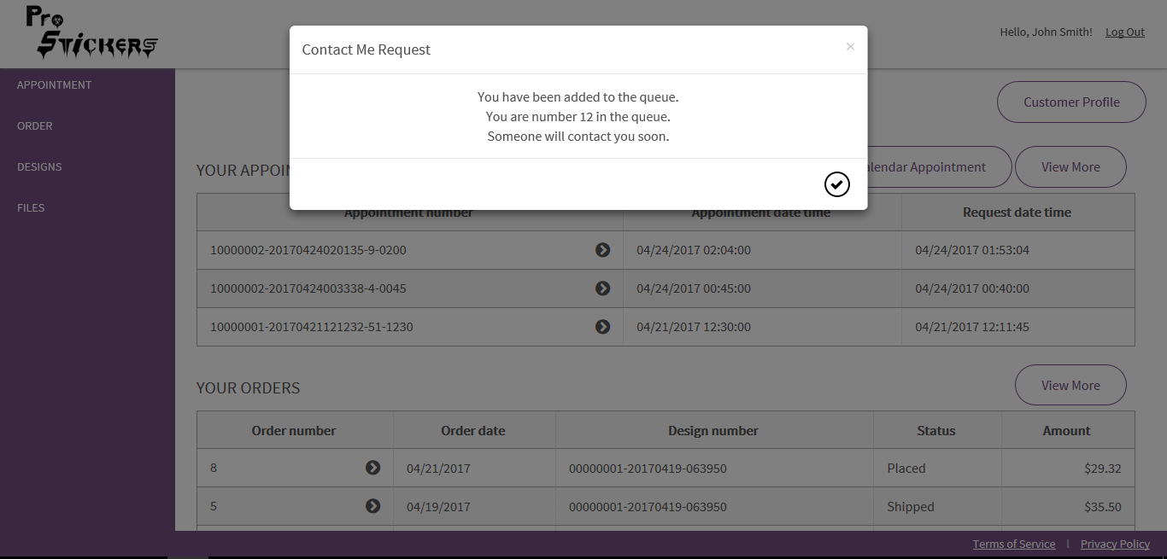

*Figure – Contact me Request (Added to the queue): Customer Portal*

* If a customer will again click Contact me, the message already in the queue will appear.

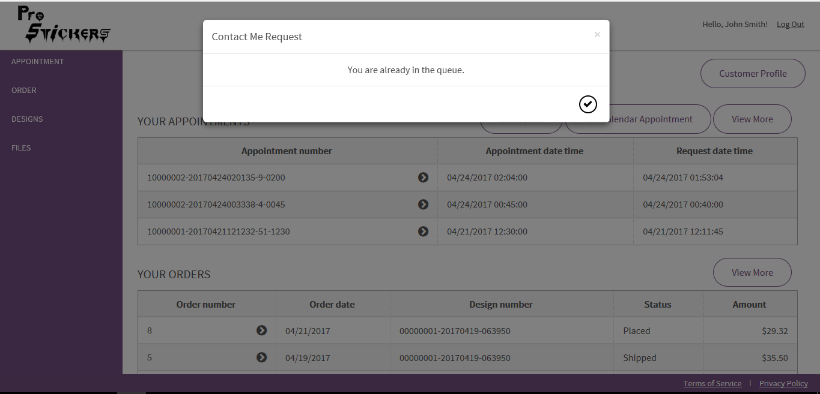

*Figure – Contact Me request (You are already in the queue): Customer Portal*

* This request will be shown on Designer Portal.
* Click on the digit as shown

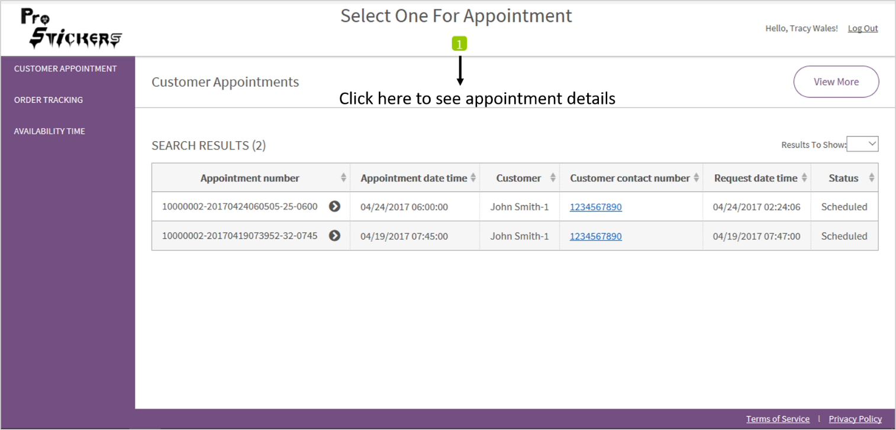

*Figure –View appointment details: Designer Portal*

* Screen will appear as shown. The Pop up is enabled with a Timer of 45 seconds.
* Here a designer can choose the date and time slot for the appointment.
* In the appointment slot, available slots saved by the designer for the date will appear.
* Once a Designer picks a contact me request, Count will reduce temporarily till request is saved as “Scheduled”. So that, no other designer can pick the same contact me request at the same time.
* If the request picked by Designer is saved with appropriate Appointment Date and time slot, then this Request will be saved as a Scheduled Appointment. It will permanently reduce the count in “Select one for Appointment” link.
* If Designer don’t save this request or closes the Pop Up (within 45 seconds) without assigning any date or time slot, then the Count will again reset so that any other Designer can pick the same contact me request.

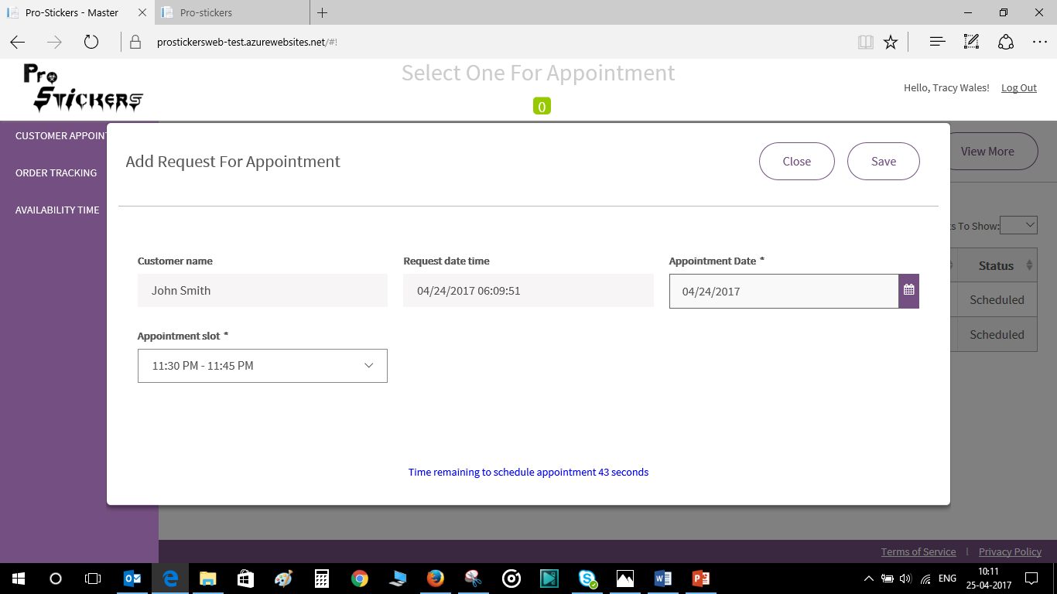

*Figure – Add request for appointment: Designer Portal*

* On time, out/Cancelling the meeting, the message “Appointment request cancelled successfully” is shown. Now the no. of request will reset to 1 (as shown in Select one for appointment)

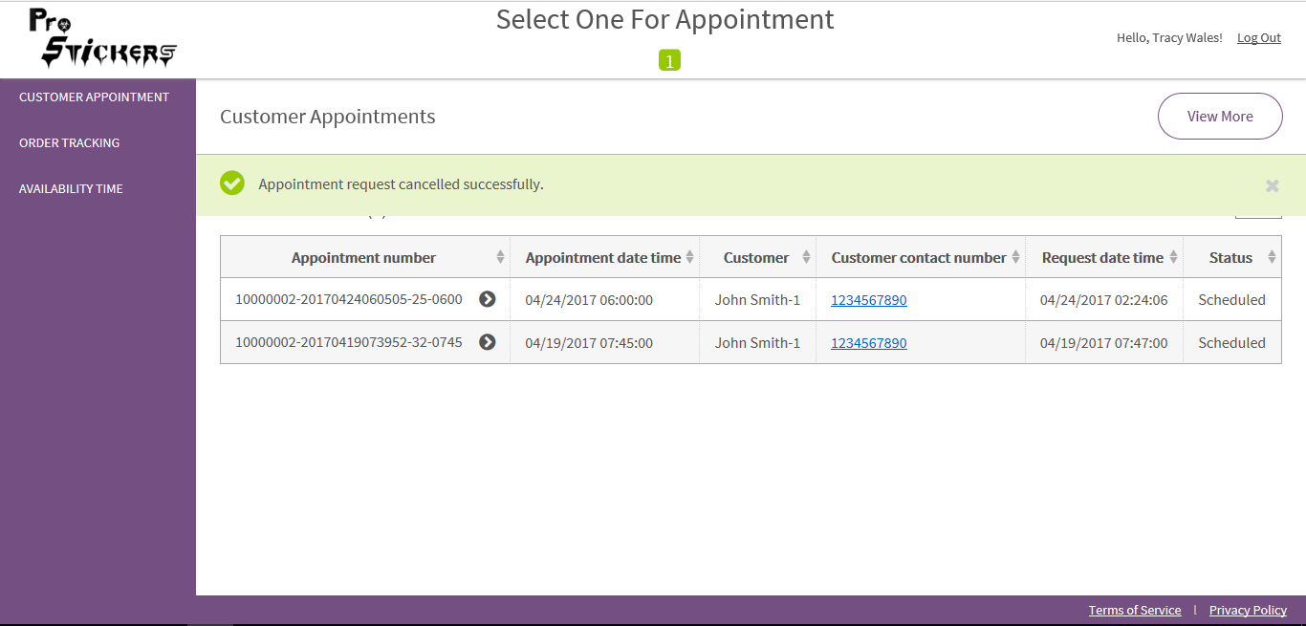

*Figure –Appointment cancellation message: Designer Portal*

* When the designer saves the appointment, in the customer’s portal ‘Connect Now’ request will appear as shown.

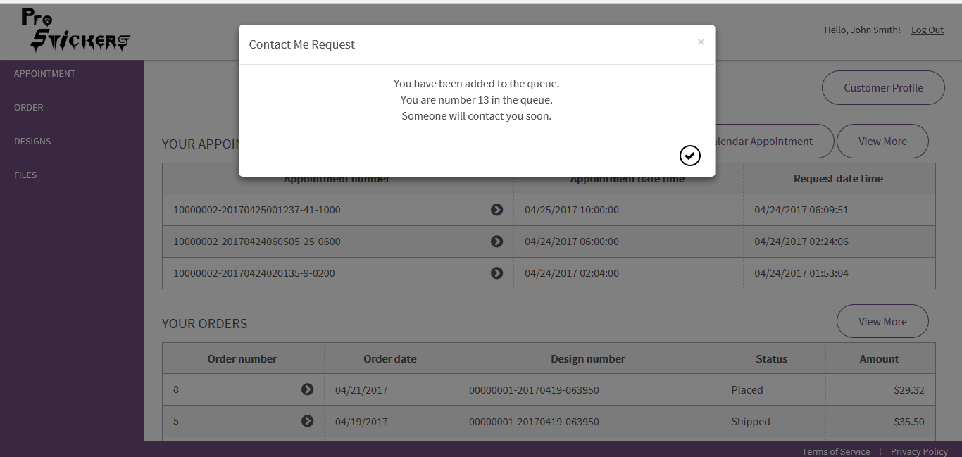

*Figure – ‘Connect Now’ request on Customer Portal: When designer saves the appointment*

* A customer can also create an appointment by Clicking on “Add Calendar Appointment”.

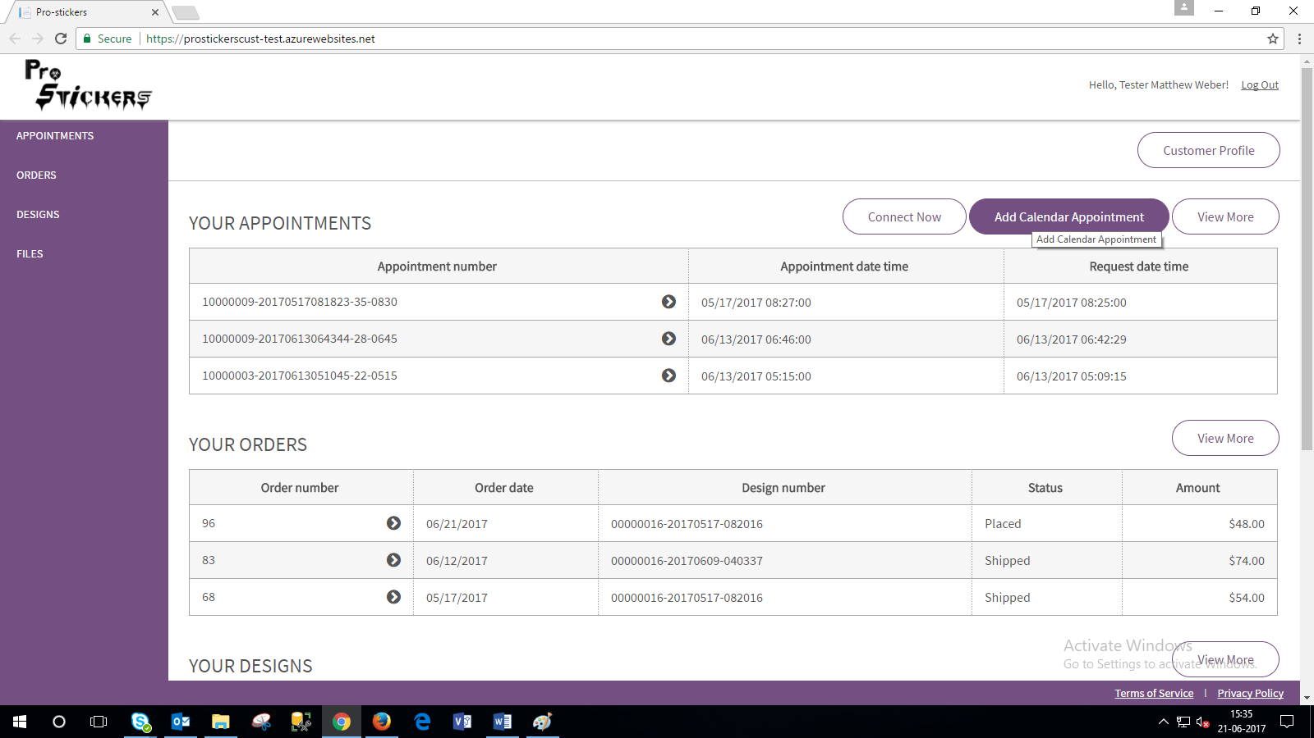

*Figure –Creating appointment by clicking on Add calendar appointment: Customer Portal*

* Add Calendar Appointment Page will appear as shown

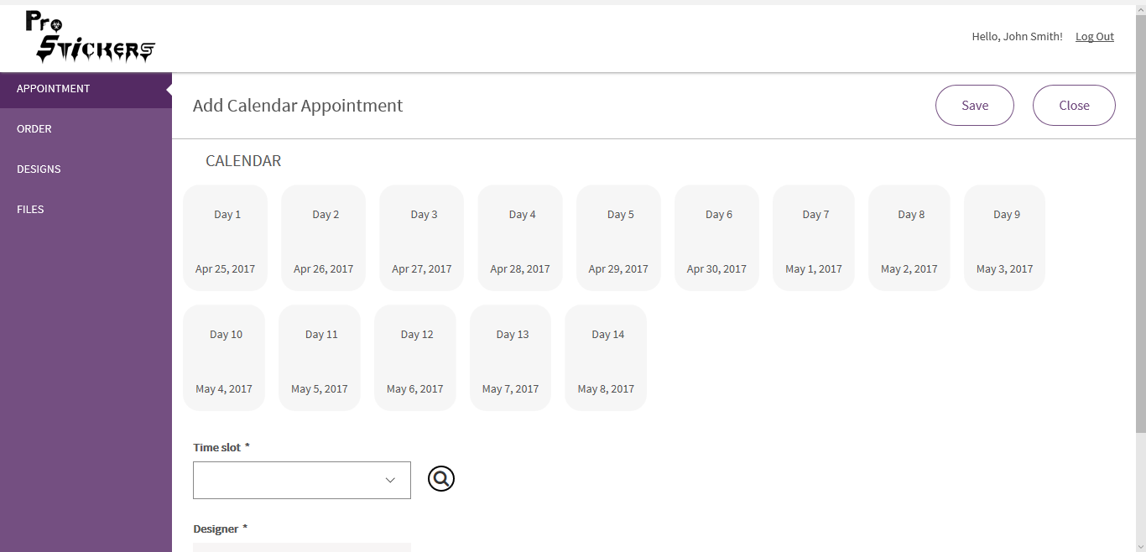

*Figure – Add calendar appointment page: Customer Portal*

* Choose the date and time for the meeting > Choose Designer > Click Save.

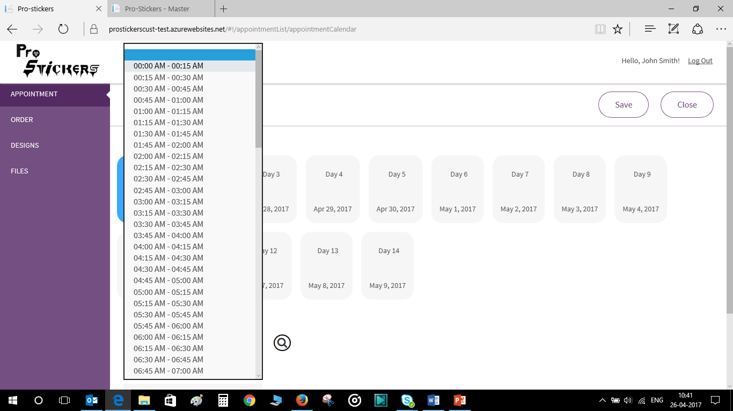

*Figure –Creating an appointment: Customer Portal*

# 14. Customer Appointment: Designer Portal

On the home page and customer appointment page recent appointments are shown. Customer will also be able to view the recent scheduled appointment.

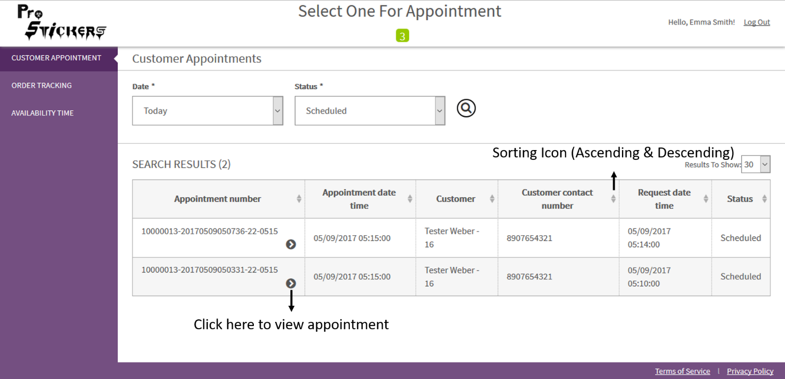

*Figure – Customer Appointment: Designer Portal*

* Appointment Details page appears as shown.
* Fill the details > Enter the Meeting link.

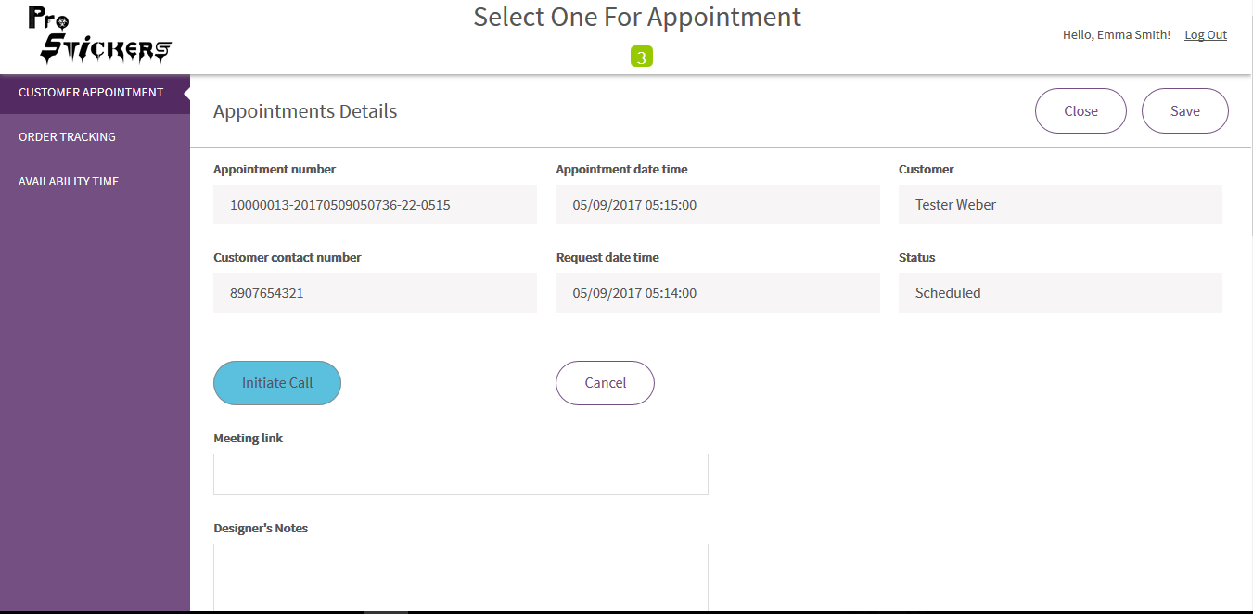

*Figure – Appointment Details Page: Designer Portal*

* Click on Initiate Call Button > Mention the time > Click on Right symbol.

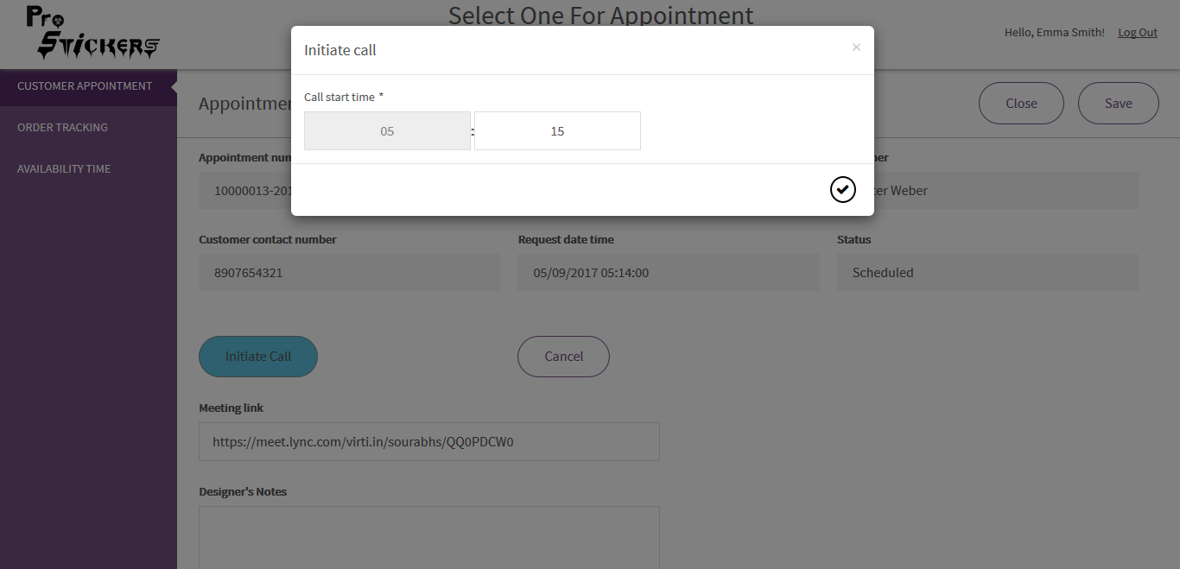

*Figure: Appointment detail – Pop up: Initiate call*

* “Appointment initiated successfully” message is shown. Customer Appointment (in customer portal) will also be reflected with same status.

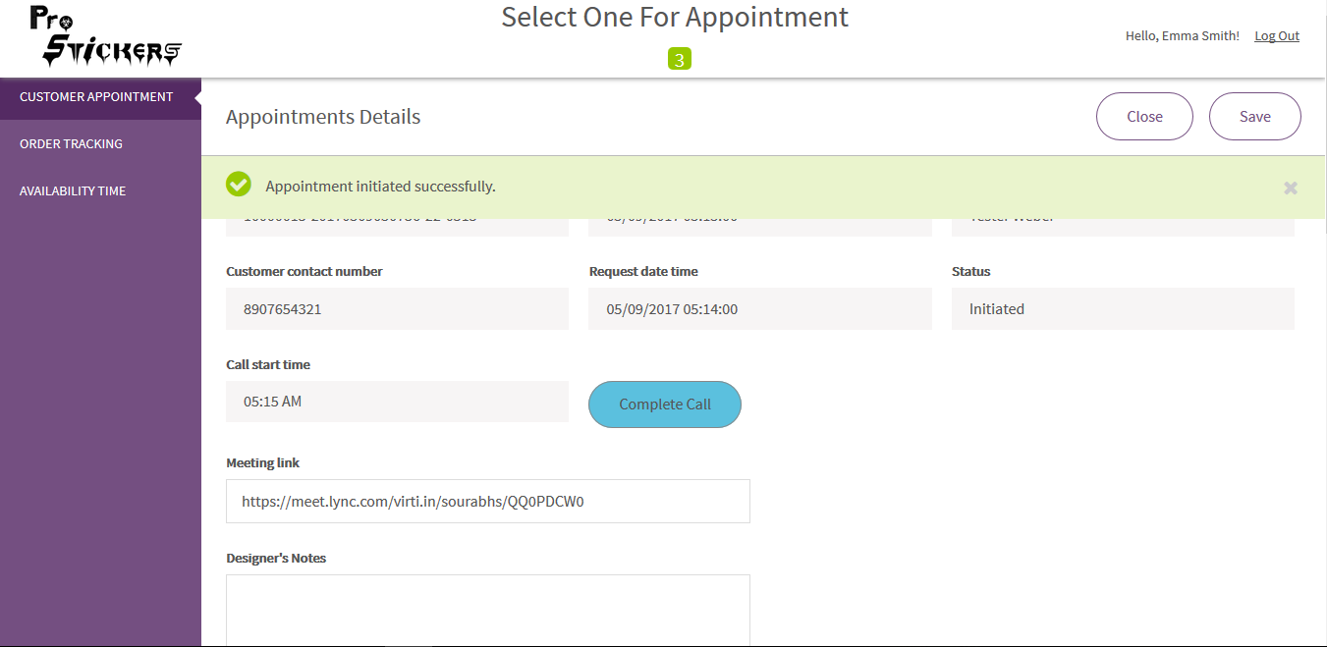

*Figure – Appointment initiated successfully message: Designer Portal*

* During the call a designer can upload design, vector and other files. A Designer can also add Designer’s Notes.

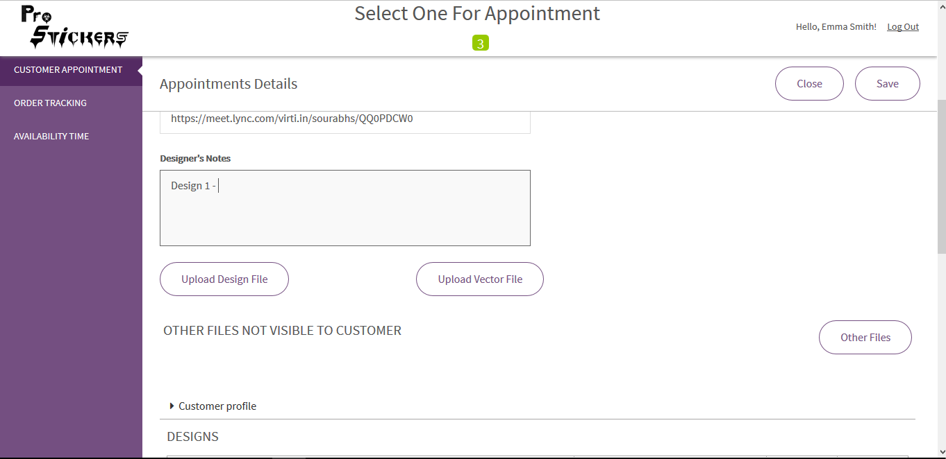

*Figure – Appointment Details Page: Designer Portal*

* View Customer Profile

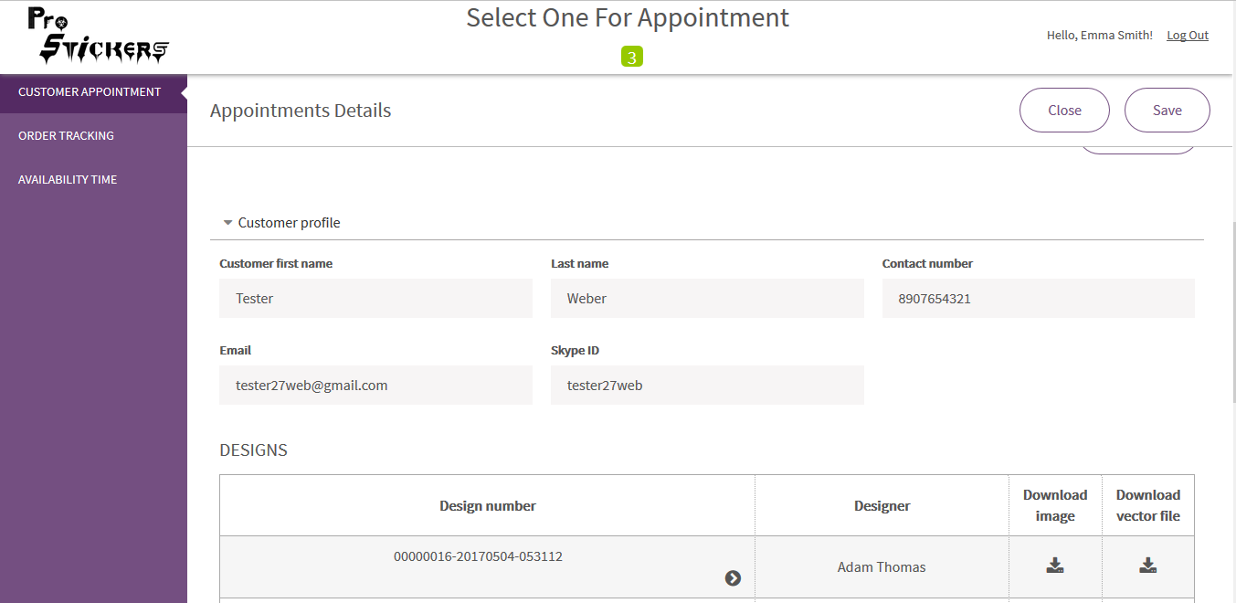

*Figure – Appointment Details Page, Customer Profile: Designer Portal*

* View/Edit previous designer’s notes, click the drill down icon in the design list > Page appears as shown.
* This form can’t be accessed by customers.

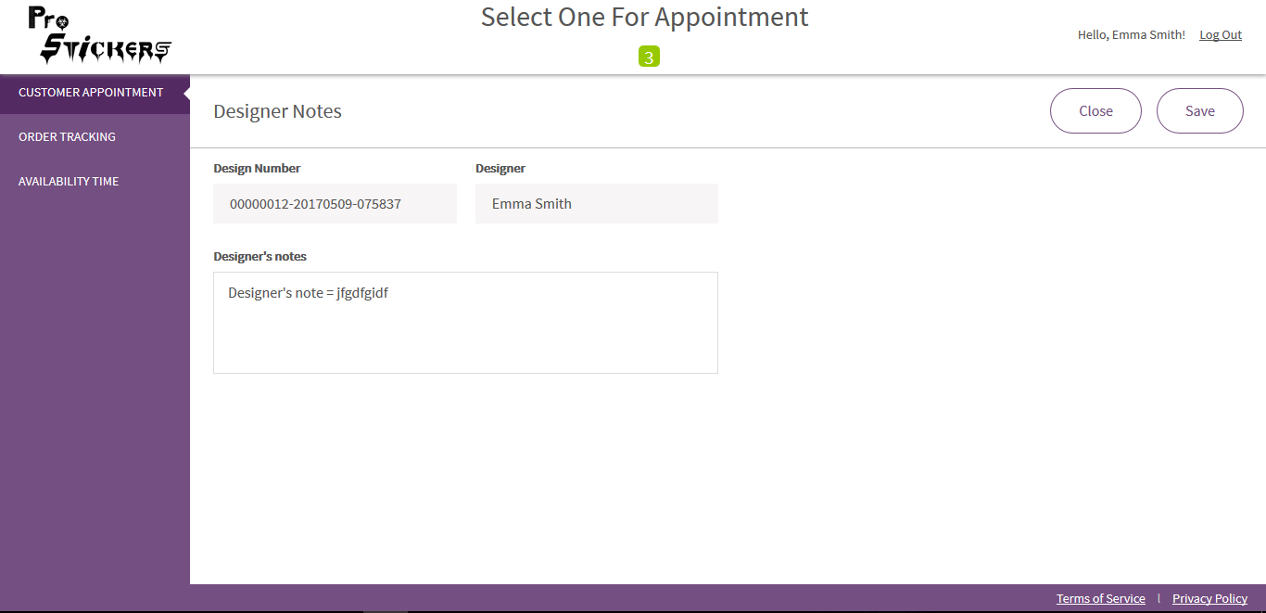

*Figure – Designer Notes: Designer Portal*

* When the call is completed click on ‘Complete Call’ button > Mention the time > Click on the right symbol.
* Customer Appointment (in customer portal) will also be reflected with same status “Completed”.

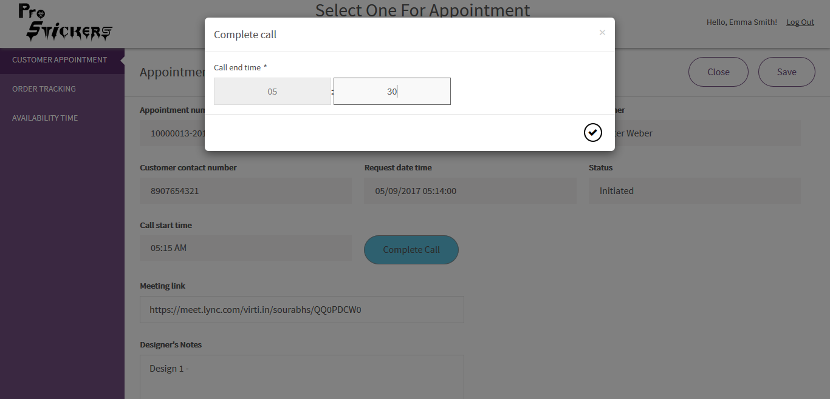

*Figure – Appointment Detail Pop up; complete call: Designer Portal*

* Message ‘Appointment completed successfully’ is shown.
* Appointment details page also exhibits the images uploaded by designer & Customer. It also shows Customer Notes.

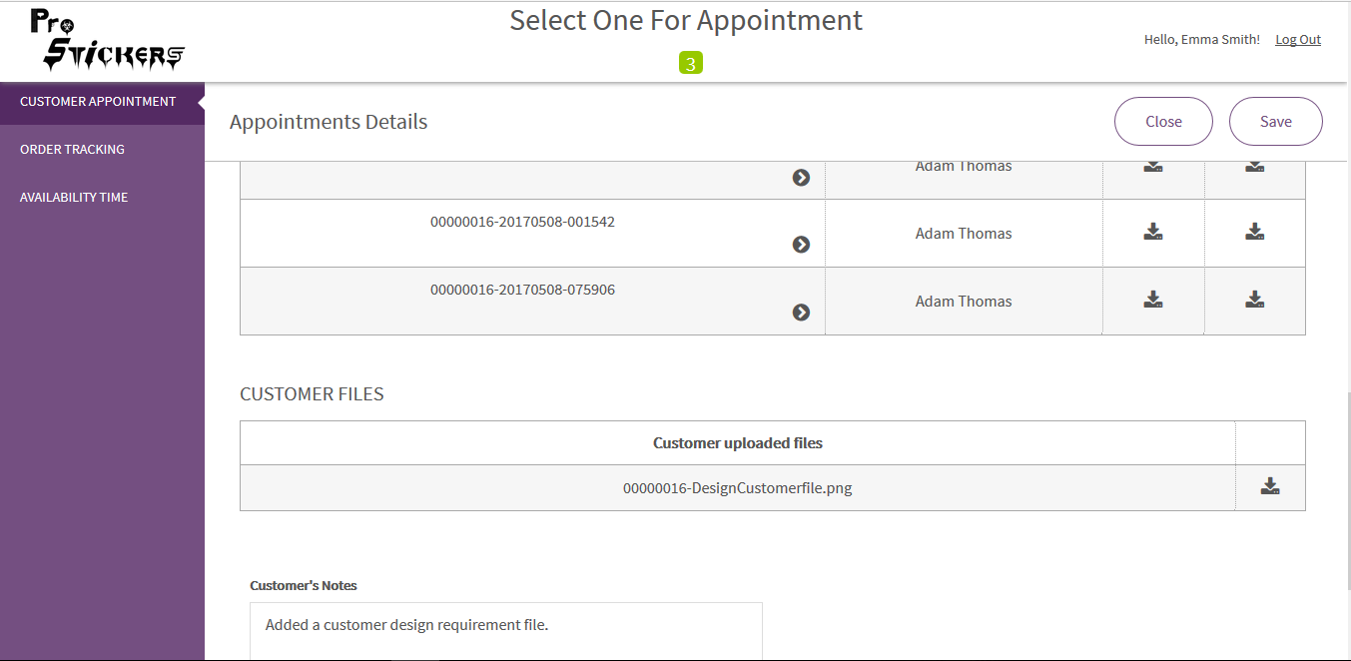

*Figure – Appointment Details page (Images uploaded by designer & customer): Designer Portal*

* Click Save > Appointment completed successfully message is shown.

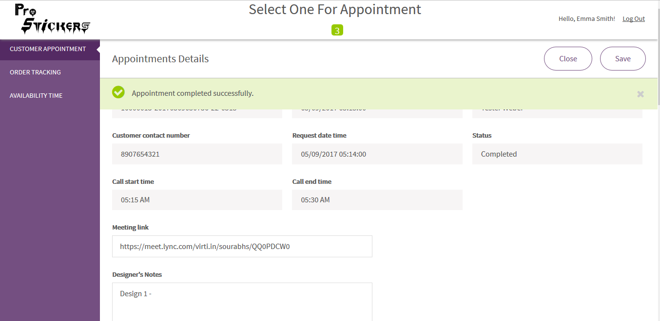

*Figure – ‘Appointment completed successfully’ message: Designer Portal*

* Meeting Cancellation: If the designer wants to cancel the meeting, cancellation reason is required.
* Click Save > A cancellation email will be sent to the respective Customer.

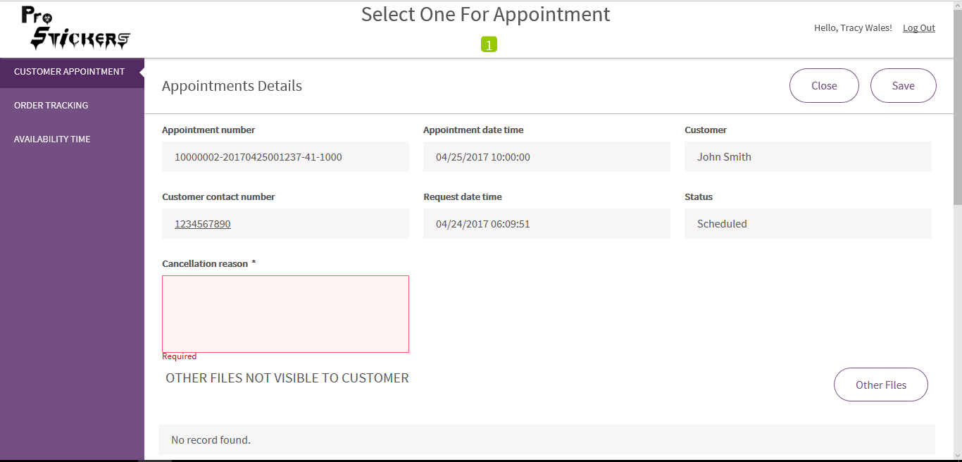

*Figure – Appointment cancellation reason: Designer Portal*

# 15. Designs: Customer Portal

When Designer uploads design image and vector file in Appointment Detail, then it will be shown in Customer portal – Design list.

* View Design list page.

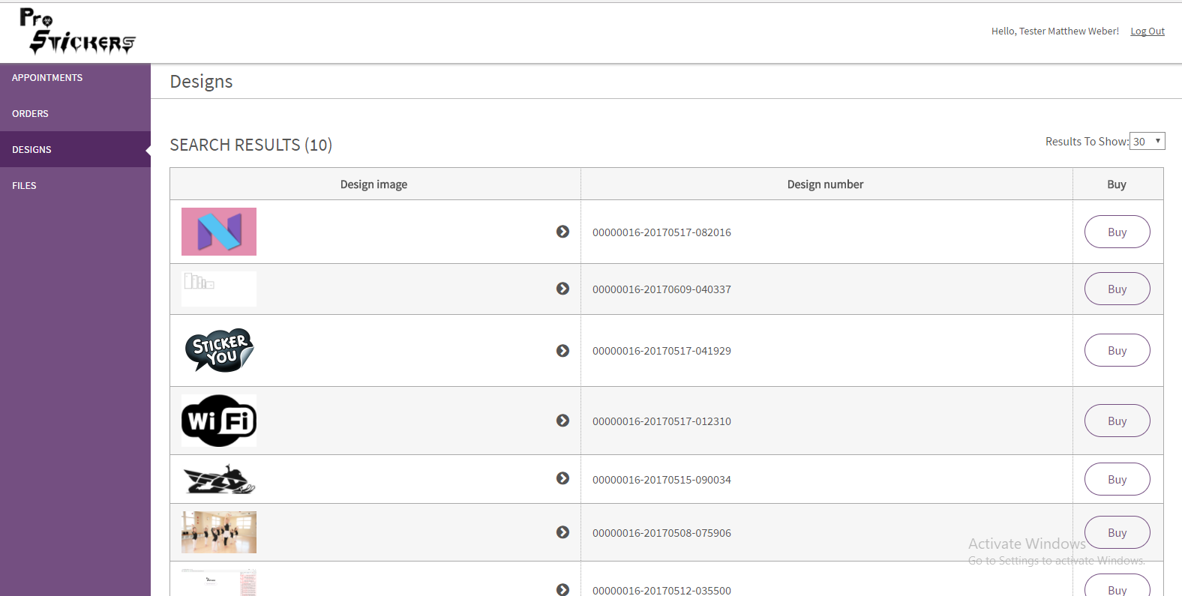

*Figure – Design List: Customer Portal*

* Design Details page appears as shown
* Click on Buy to create an Order.

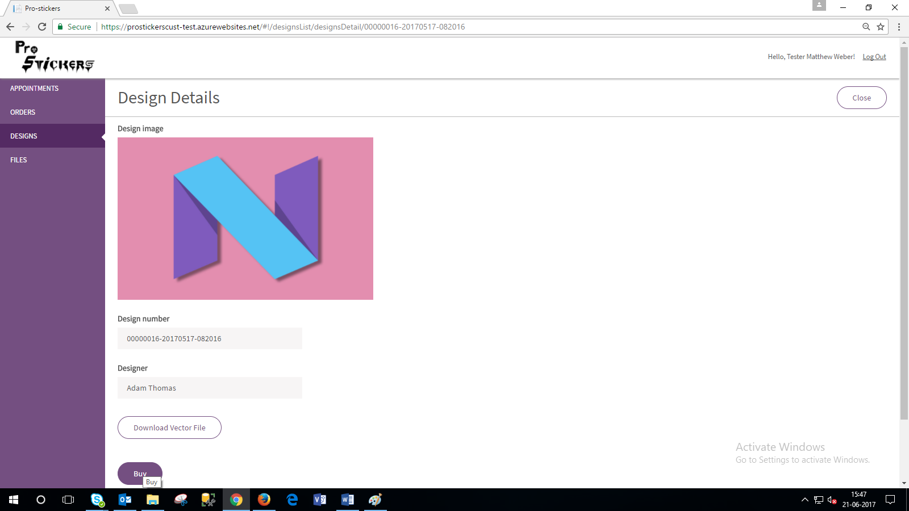

*Figure – Creating an order from Design Details Page: Customer Portal*

* Design can also be purchased from Appointment Detail page.

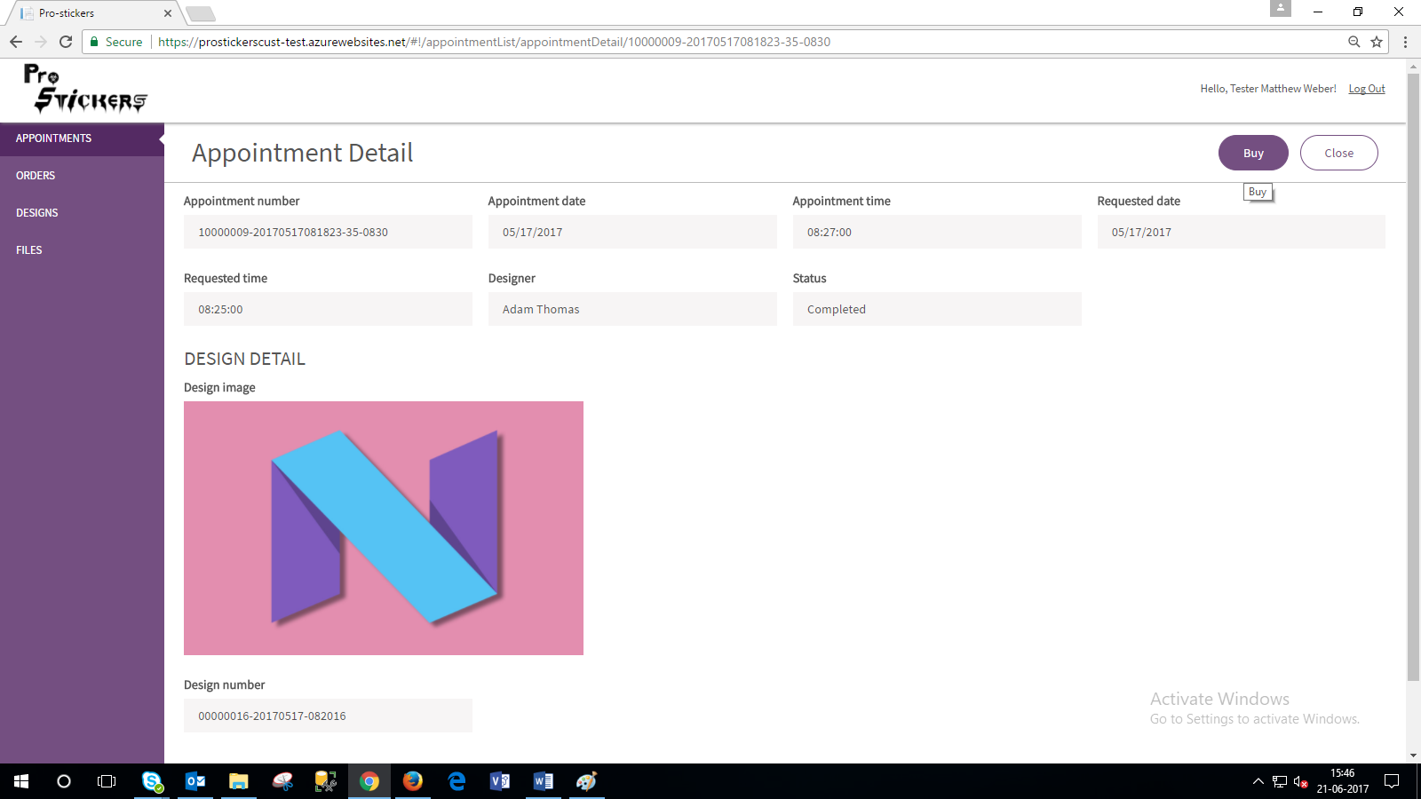

*Figure – Creating an order from Appointment Detail Page: Customer Portal*

* Design can also be bought from design list page.

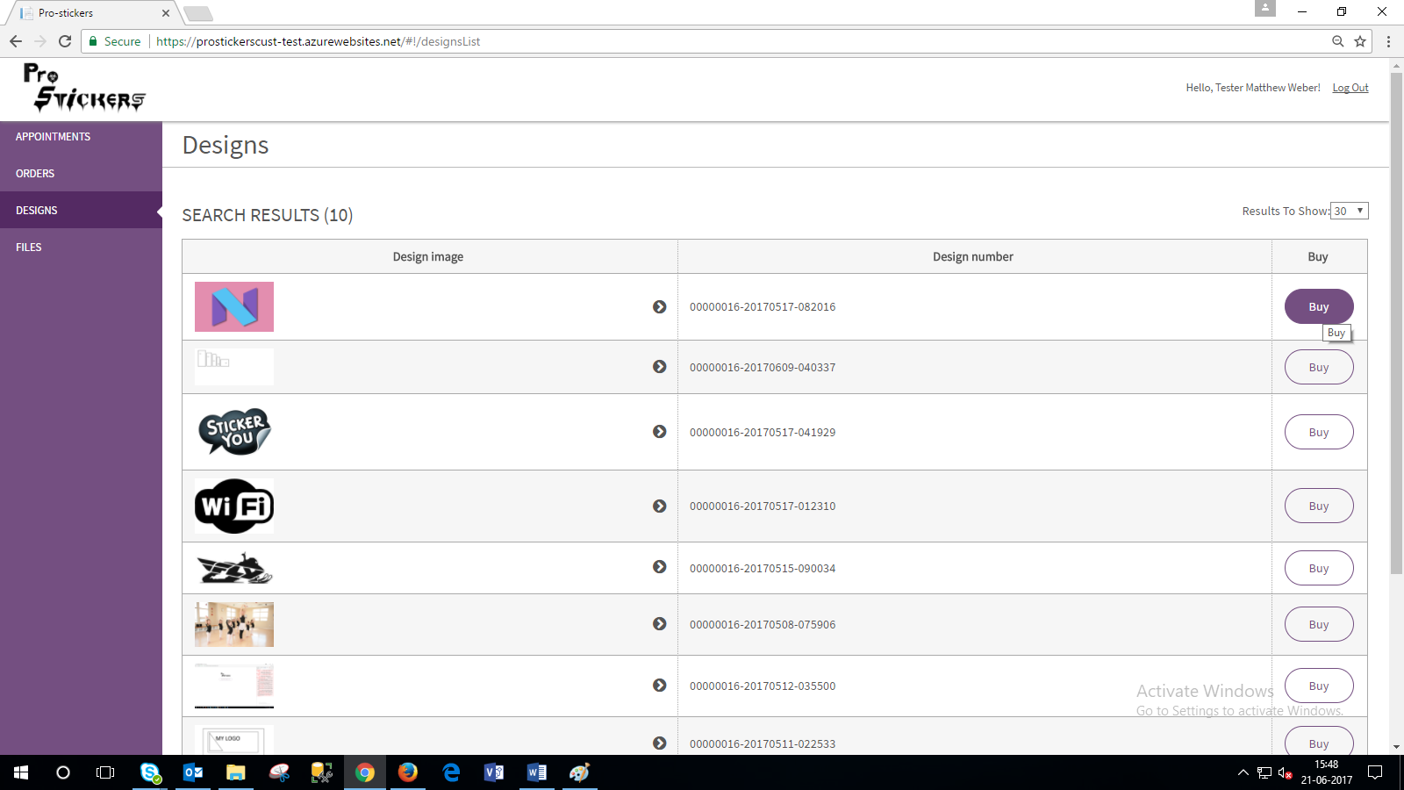

*Figure – Creating an order from Design Page: Customer Portal*

* The below Order page appears when Buy is clicked on Design detail page, Design list page or Appointment detail page.

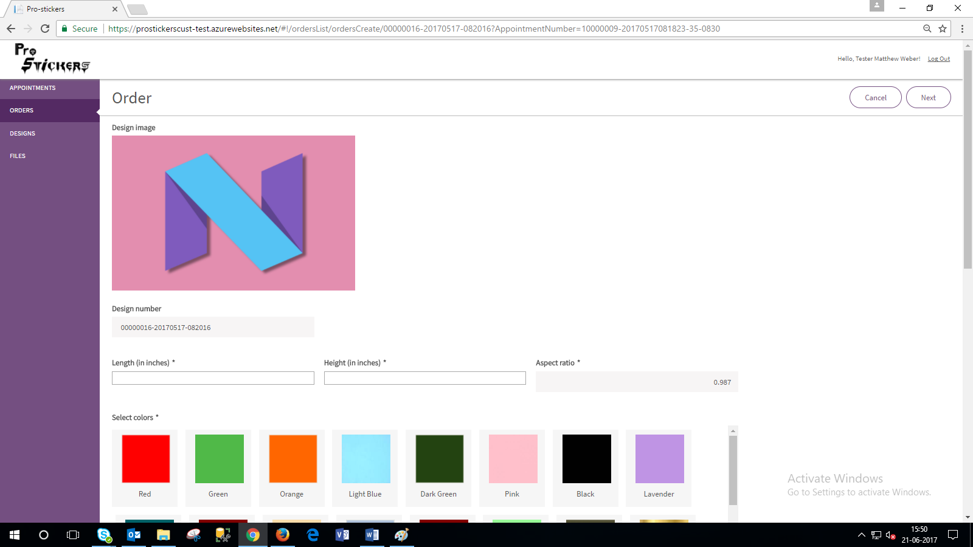

*Figure – Order Page: Customer Portal*

* Fill the required details
* Select color – Minimum 1 Color and maximum 5 colors can be chosen.

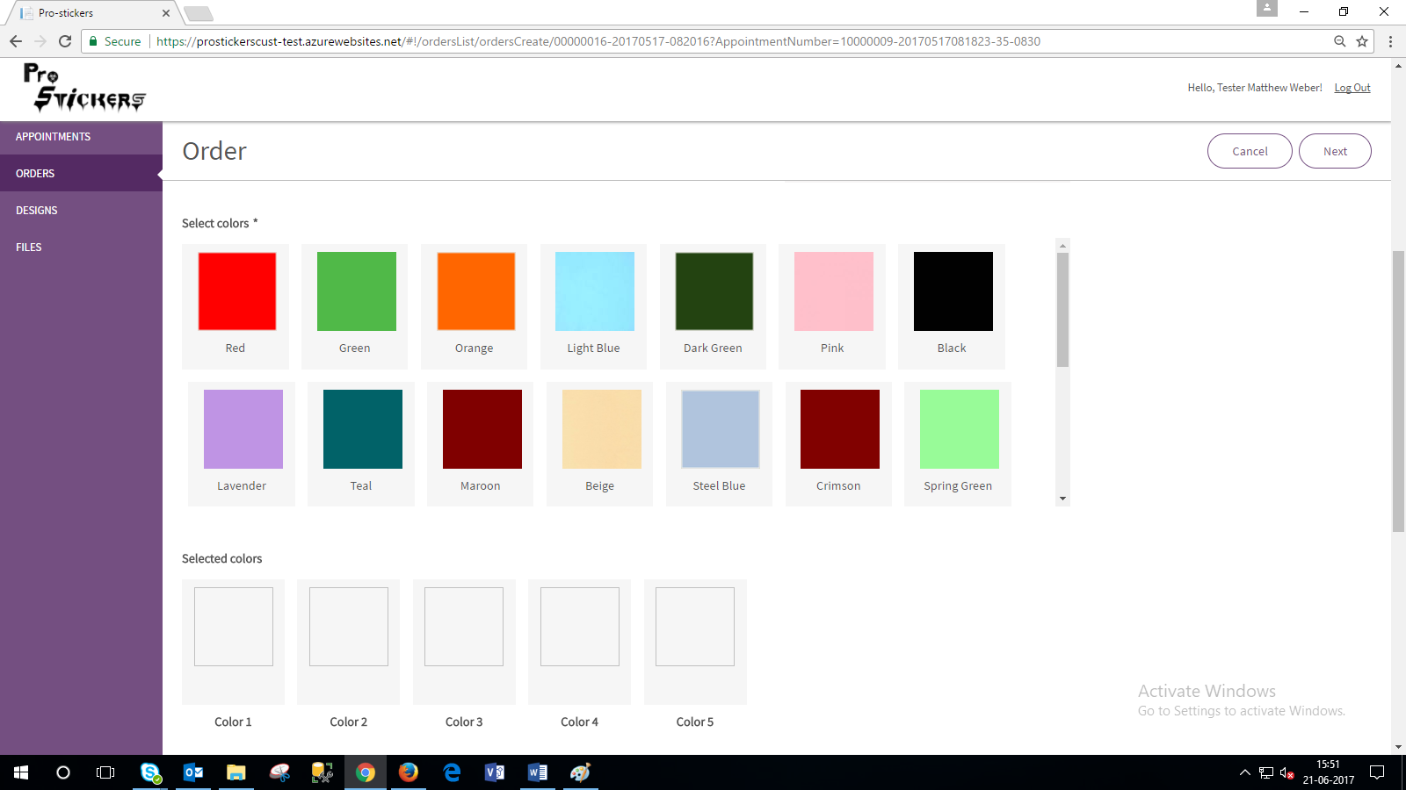

*Figure – Creating an order: Customer Portal*

* The colors which are selected are shown under Selected Colors.

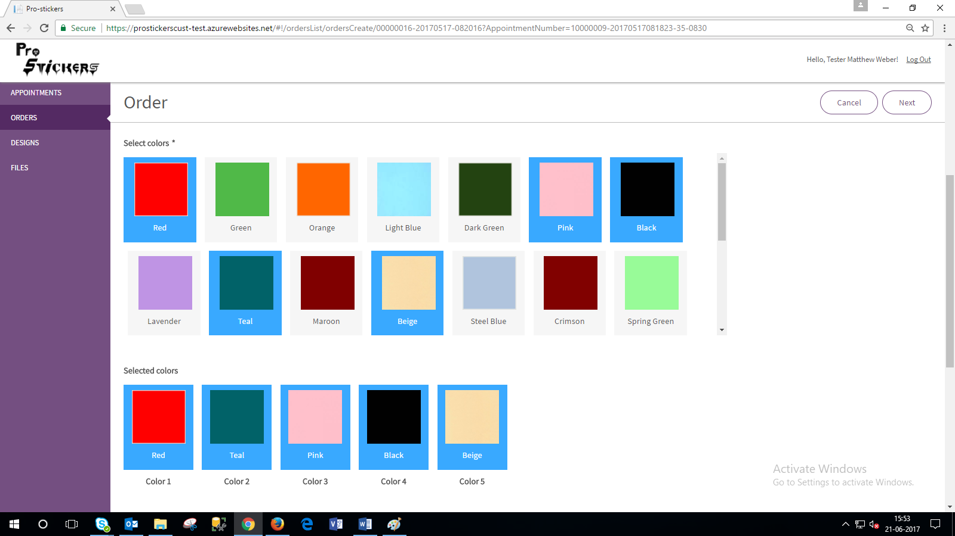

*Figure – Colors’ Selection- Order Creation: Customer Portal*

* Purchase Design Sticker’ Checkbox: Multiple orders can be created.
* Purchase vector file’s checkbox: One time order allowed
* Maximum value (length or width), Pre-defined Price based on number of selected color(s) are considered to calculate the final pricing of Design Sticker.
* Shipping price is also added in Total amount.

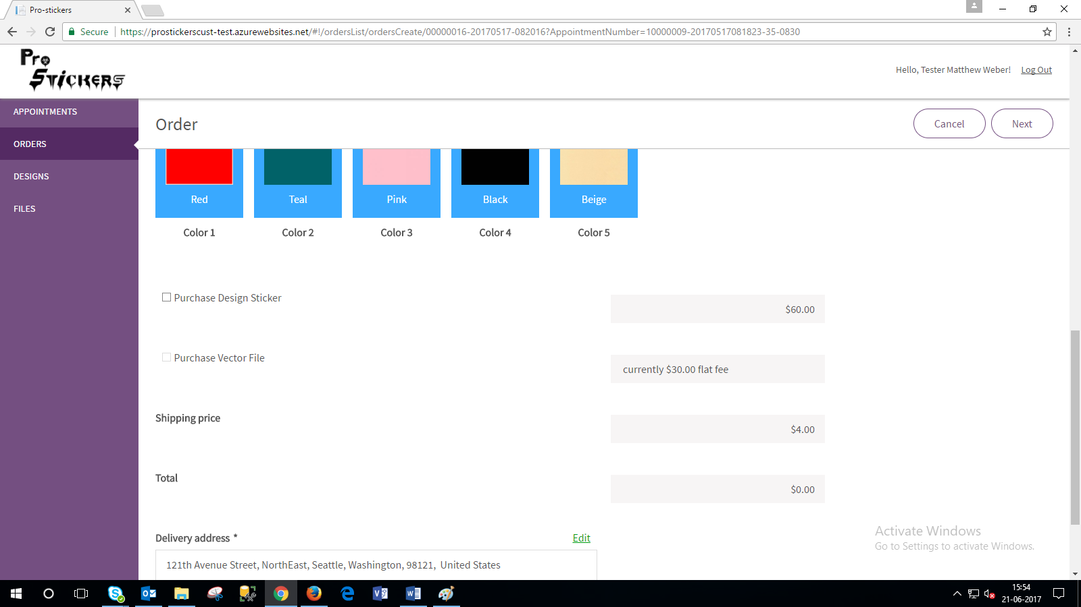

*Figure – Order Creation: Customer Portal*

* Delivery Address will be auto filled, it can be edited.
* Edit Delivery Address > Click on the right symbol > Click Next

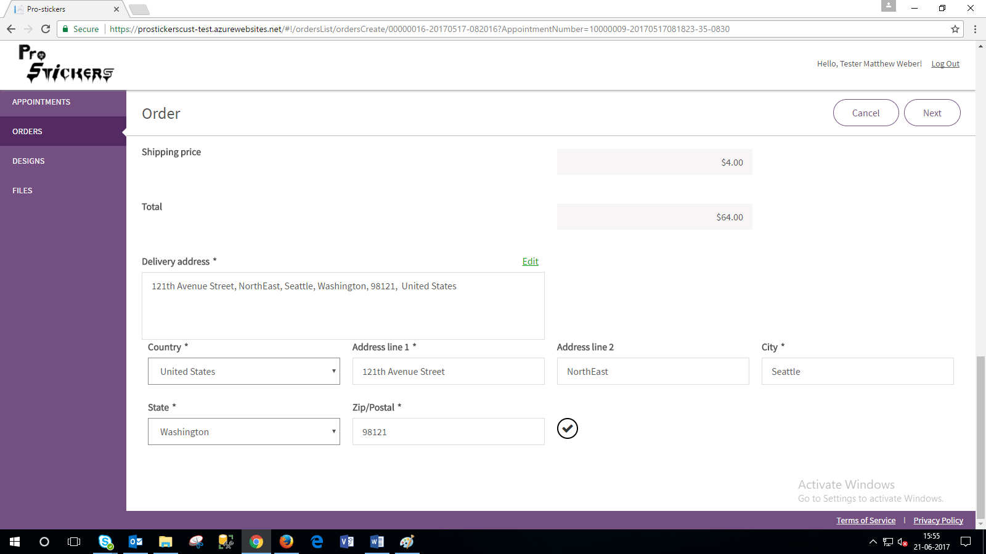

*Figure – Creating an order, Edit Delivery Address: Customer Portal*

* Page will appear as shown > Fill the required payment details > Pay
* Message: ‘Order placed successfully with order no: _’ is shown.

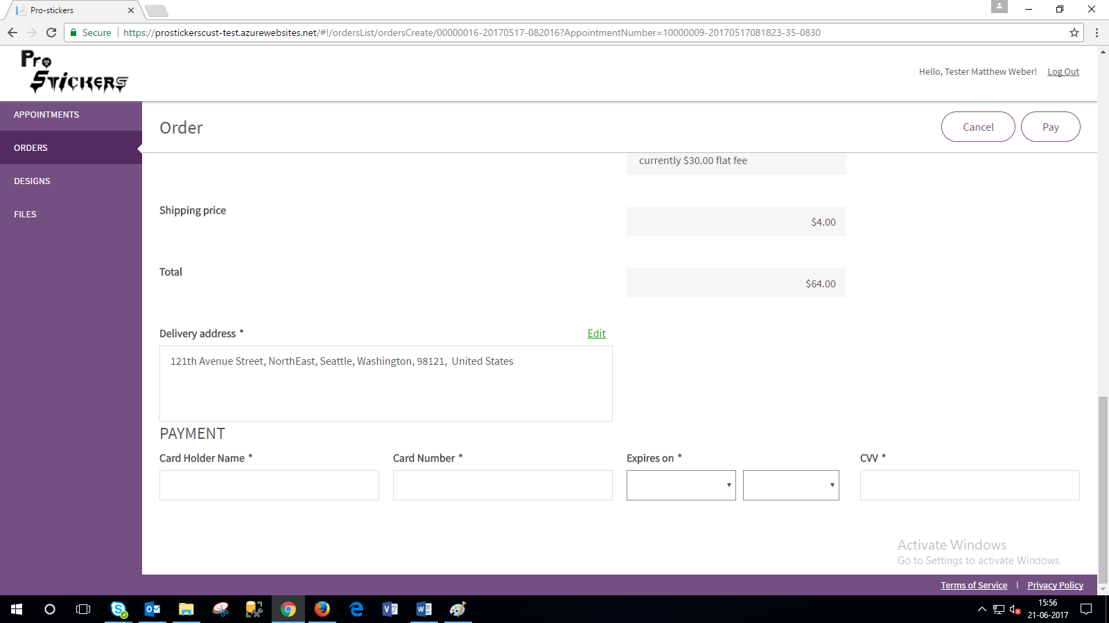

*Figure – Creating an order (Payment Page): Customer Portal*

# 16. Order: Customer Portal

Click on Order > Order list Page appears as shown

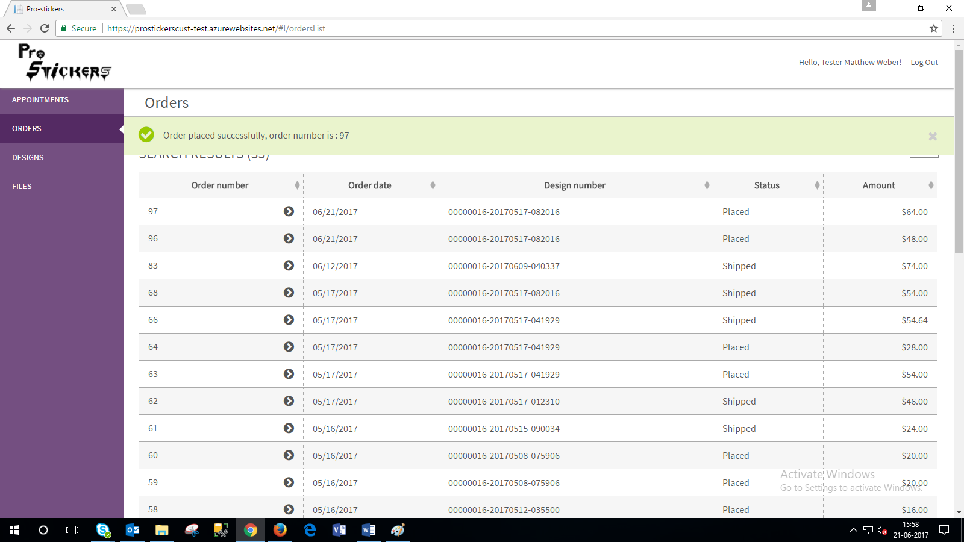

*Figure – Order Page: Customer Portal*

* Order Detail Page
* When order is shipped, tracking number and tracking link appears.

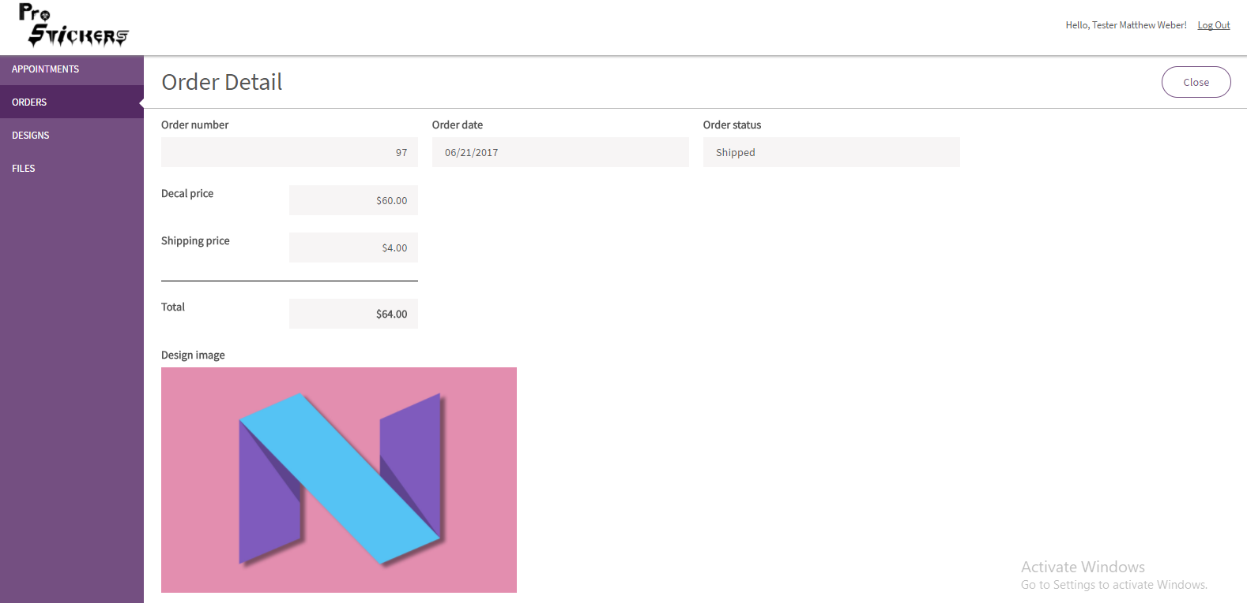

*Figure – Order Detail Page (i): Customer Portal*

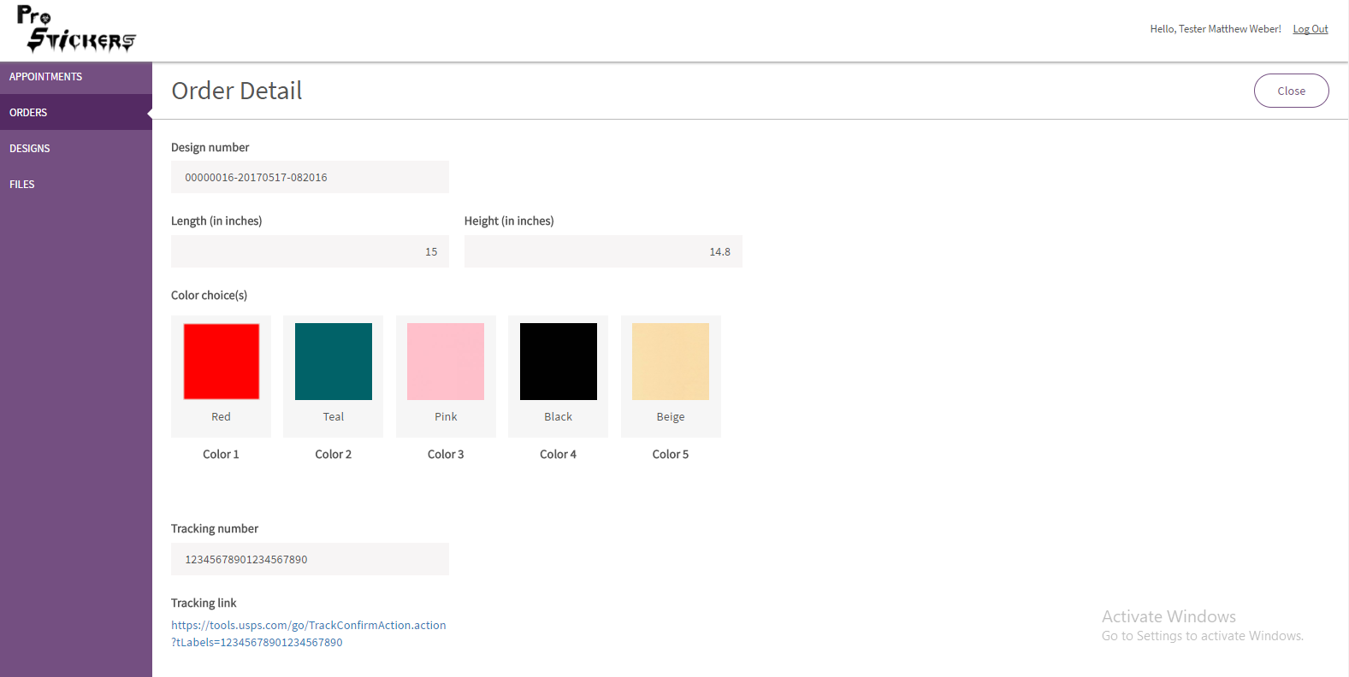

*Figure – Order Detail Page (ii): Customer Portal*

# 17. Order Tracking (Master/Designer)

* Order Tracking Number Form: Master

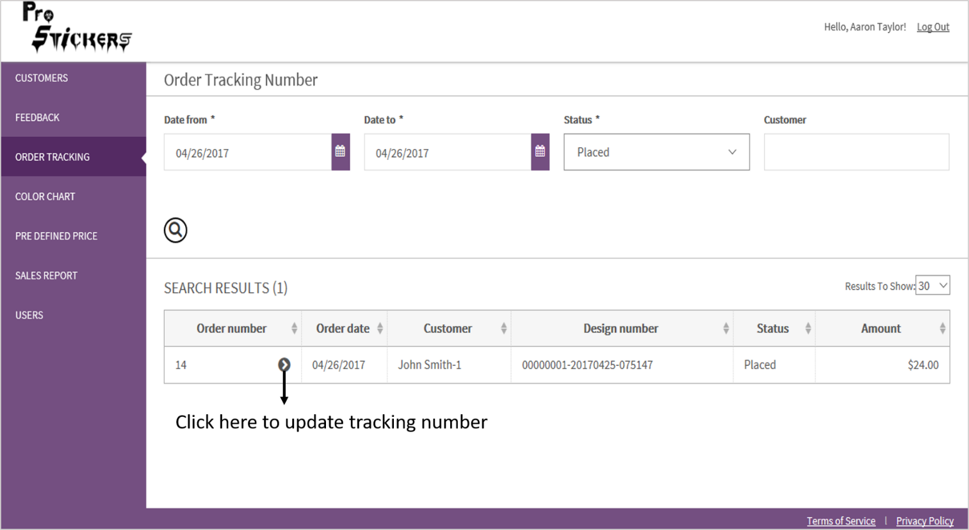

*Figure – Order Tracking Number page: Master Portal*

* Order Tracking Number Form: Designer

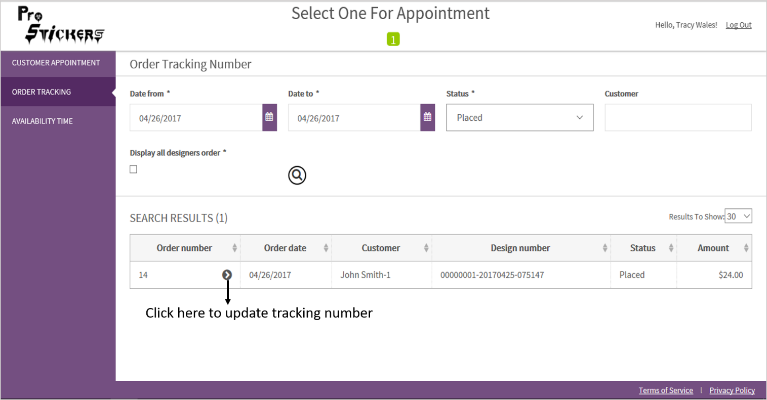

*Figure – Order Tracking Number page: Designer Portal*

* Update tracking form appears as shown.
* It will show – Order Details, Customer Details, and Design Details.
* Enter the tracking number and click save.
* After updating the tracking number, the status of the Order will be shown as ‘Shipped’.

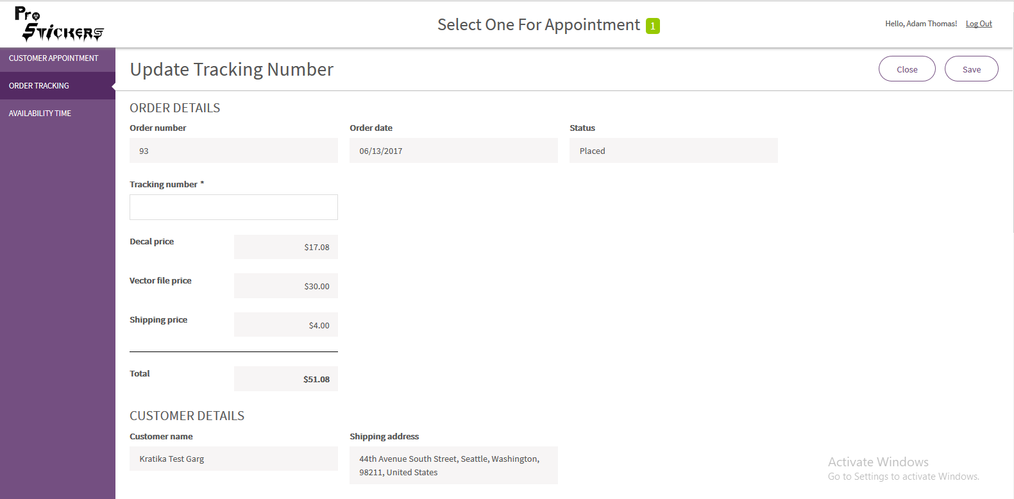

*Figure – Update Tracking Number page (i): Designer Portal (also in master portal)*

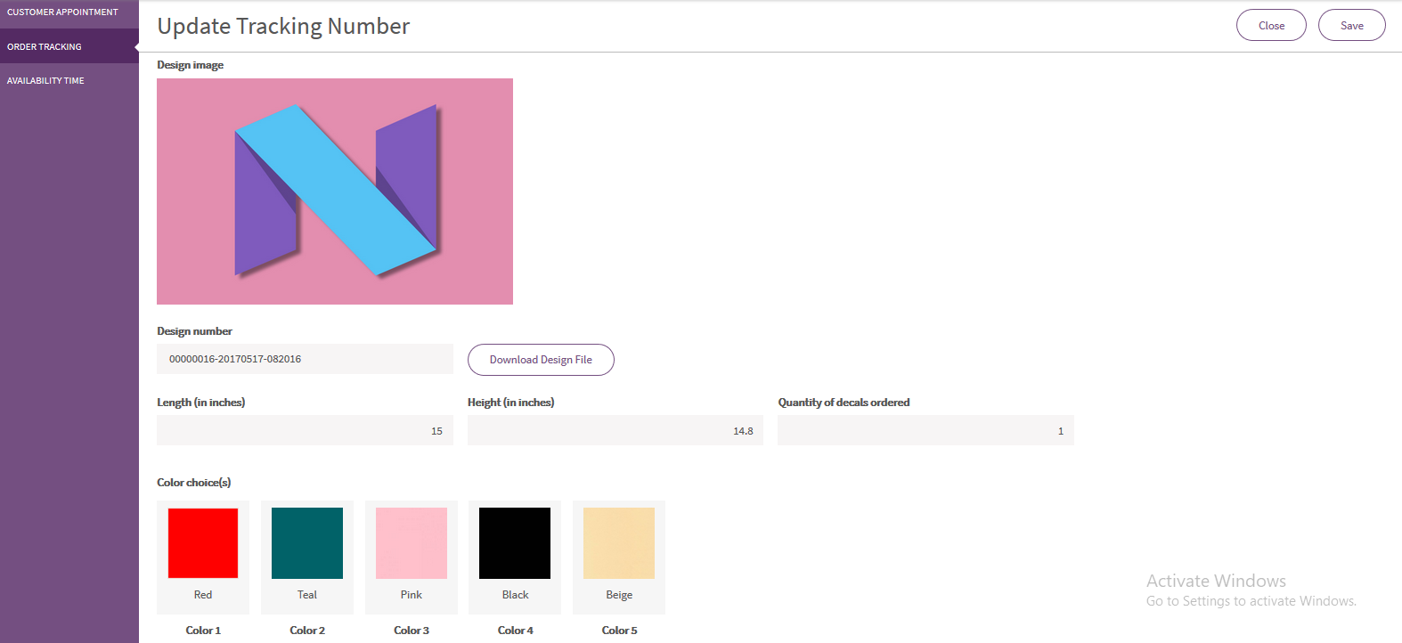

*Figure – Update Tracking Number page (ii): Designer Portal (also in master portal)*

# 18. Customer Portal: Customer Feedback

* After creating an order a customer can give the feedback.
* Giving a feedback is an option in the hands of customer.

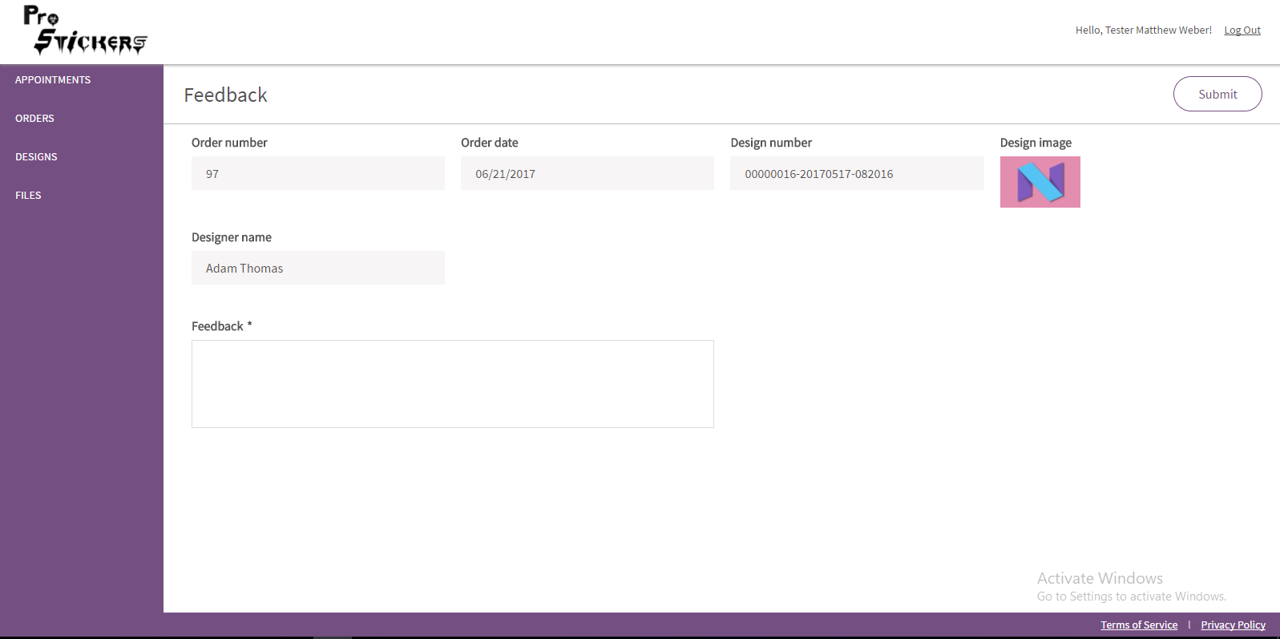

*Figure – Feedback Page: Customer Portal*

* Master can view the feedback on either home page or feedback list page of Master portal.

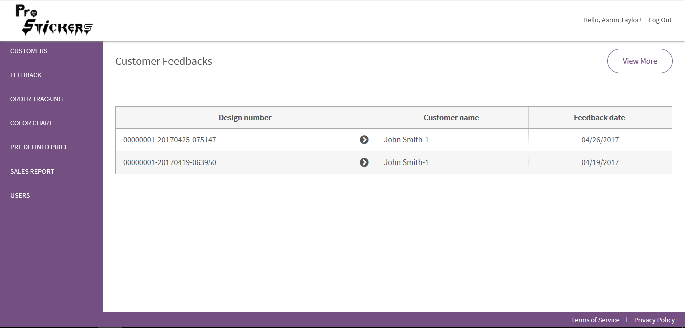

*Figure – Customer Feedbacks page: Master Portal*

* A master has the below options regarding feedback given by customer.
* Give a reply to the feedback.
* Display the customer feedback with or without reply on Public website.
* Delete a feedback.

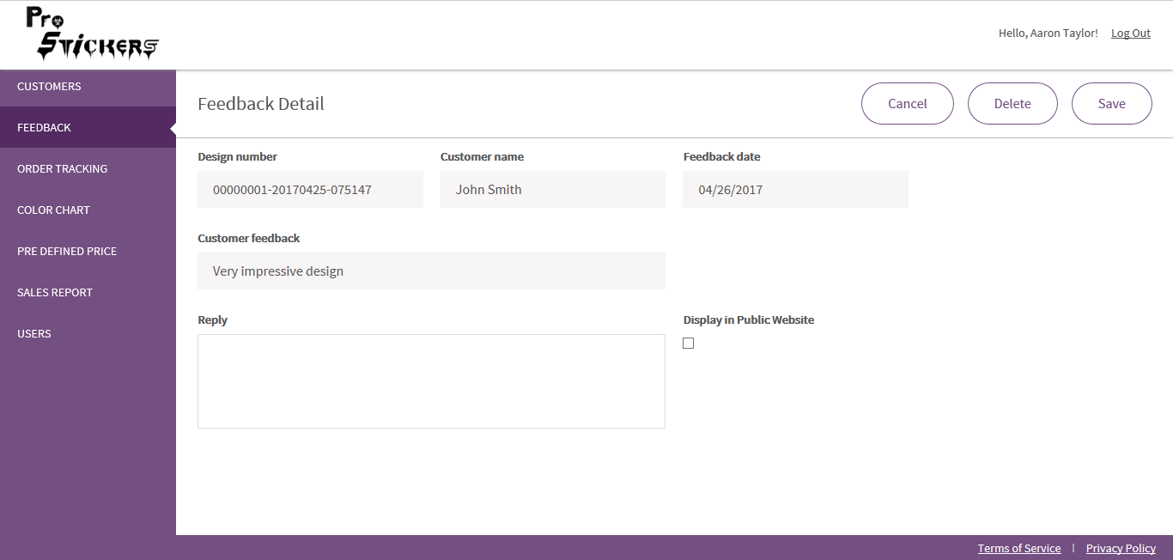

*Figure – Feedback Detail Page: Master Portal*

# 19. Sales Report: Master Portal

Click on Sales Report > Sales report page appears as shown.

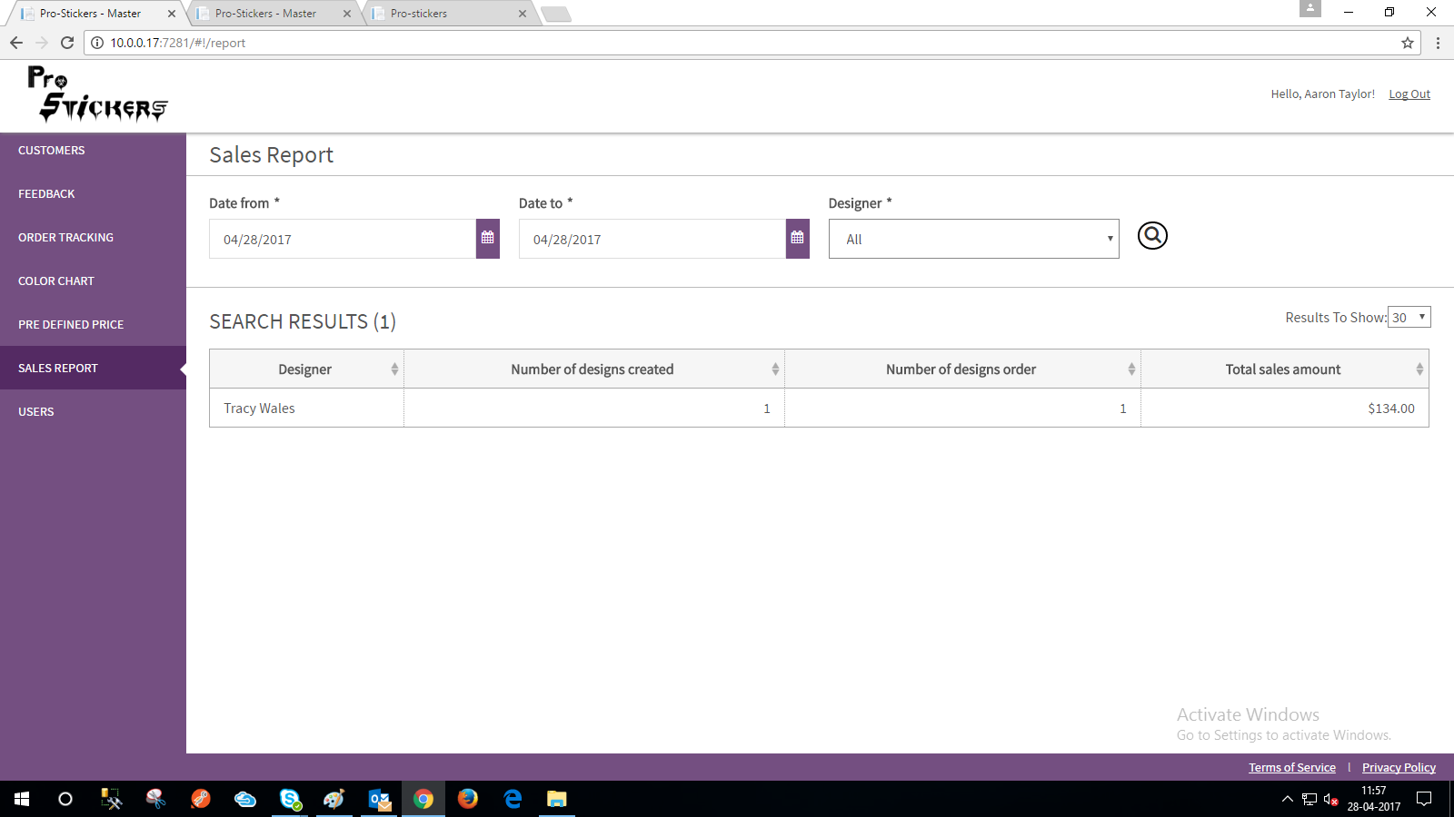

*Figure – Sales Report: Master Portal*

* Sales report can be shown based on Different filters
* Date from
* Date to
* Designer (all/individual)

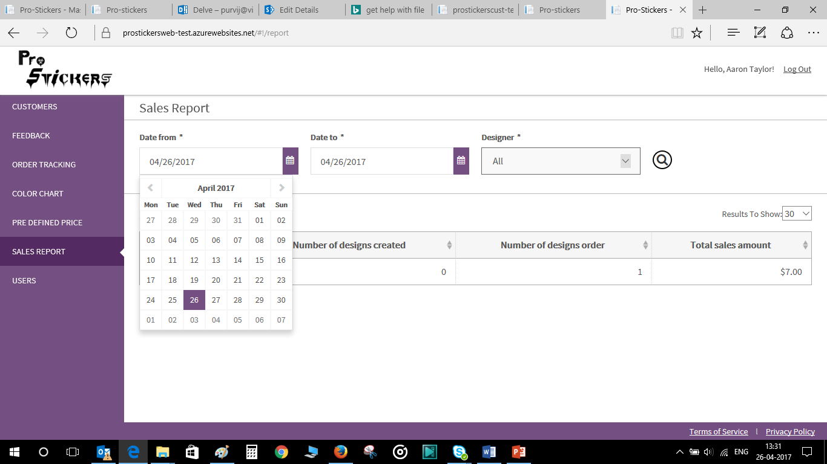

*Figure – Sales Report: Master Portal*

# 20. Design Detail: Customer Portal (Order Placed)

Click on Design > Page appears as shown

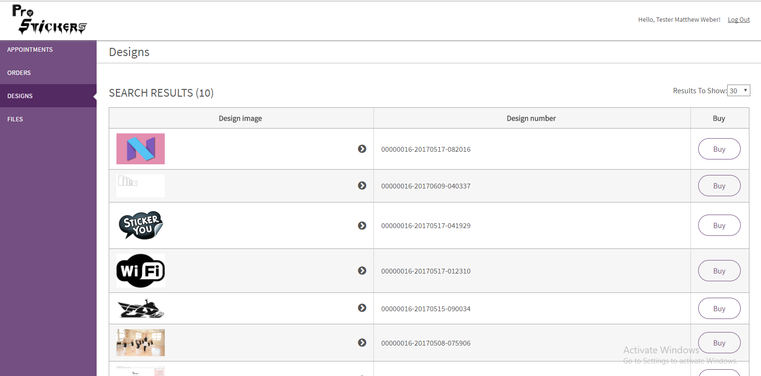

*Figure – Design page: Customer Portal*

* Design details page appears as shown
* Download Vector file option will appear in case vector file is purchased.
* Delete: If design sticker is purchased and order is shipped then only design image can be deleted.

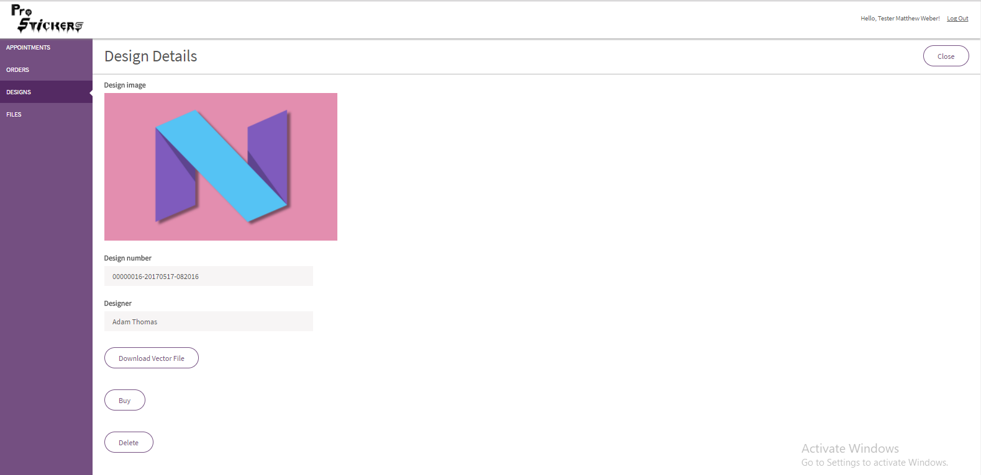

*Figure – Design Details page (In case order has been shipped): Customer Portal*

# 21. Files: Customer Portal

* From this page, a customer can upload files and edit notes.

Maximum number of files can be uploaded here is 10 and Maximum size for all files together is 20 MB.

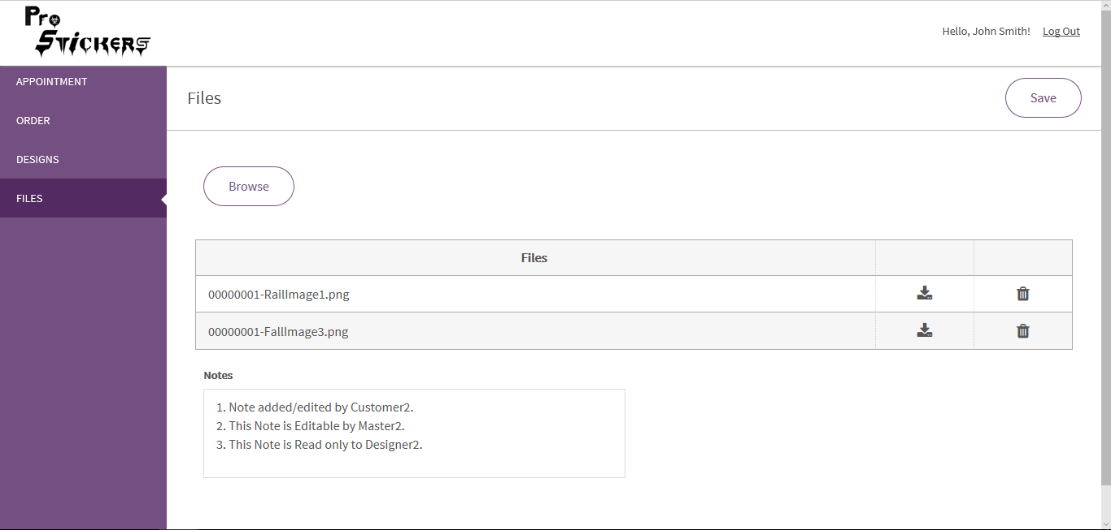

*Figure – Files page: Customer Portal*

# 22. Customer Detail: Master Portal

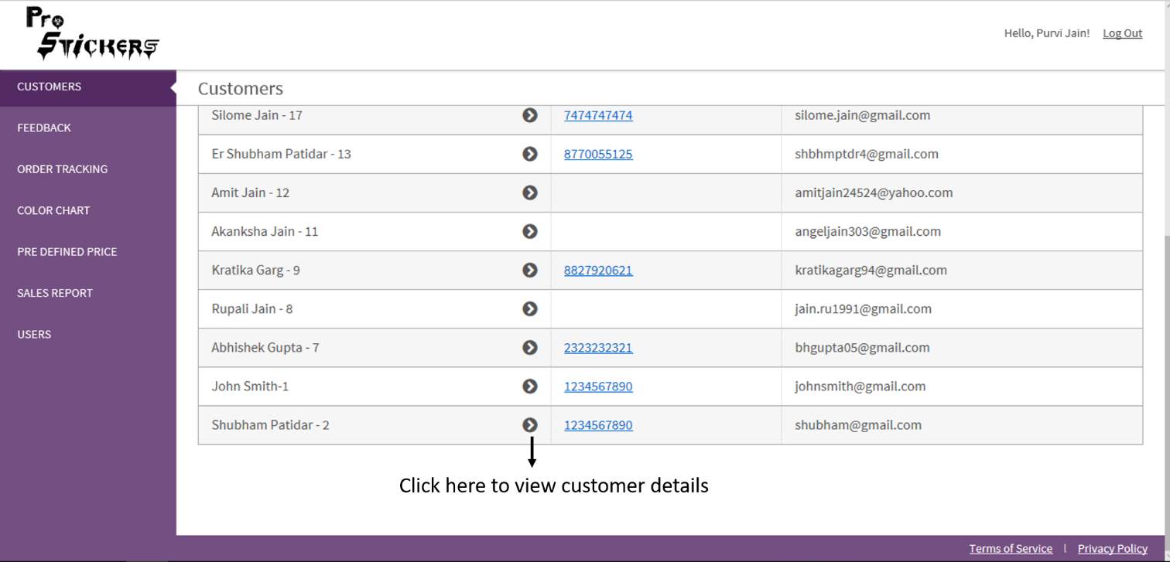

*Figure – Customer List page: Master Portal*

* Customer Detail page appears as shown.

A Master here can edit customer details and delete a customer.

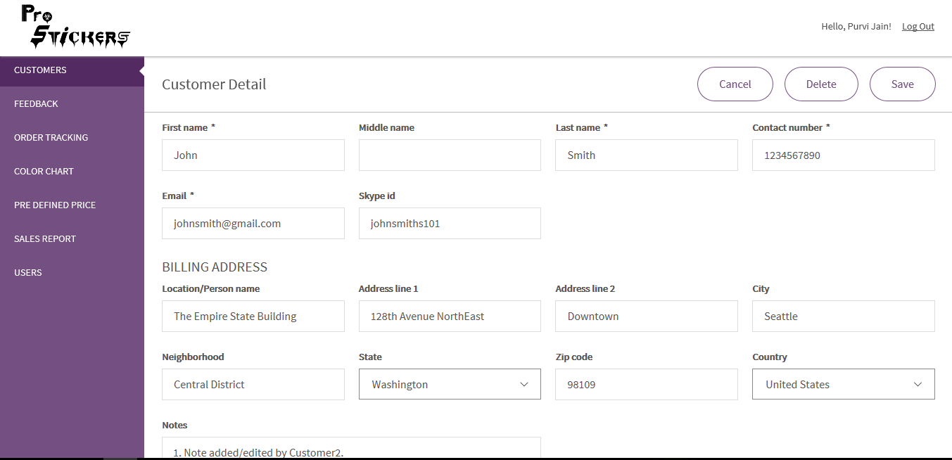

*Figure – Customer Detail page: Master Portal*

* Here, Master can access following items in Customer Detail form:
* files uploaded by customer,
* designs created for that customer and
* other files not visible to customer

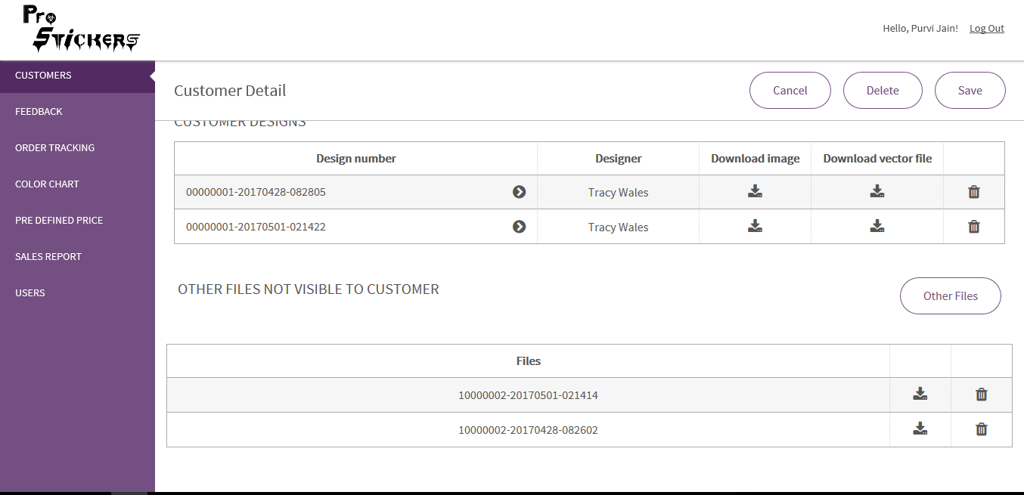

*Figure – Customer Detail page: Master Portal*

Click here to view design detail